**B. PROJECT DEPLOYMENT IN THE AWS CLOUD USING EC2 INSTANCE**

Log in to AWS and Go to EC2.

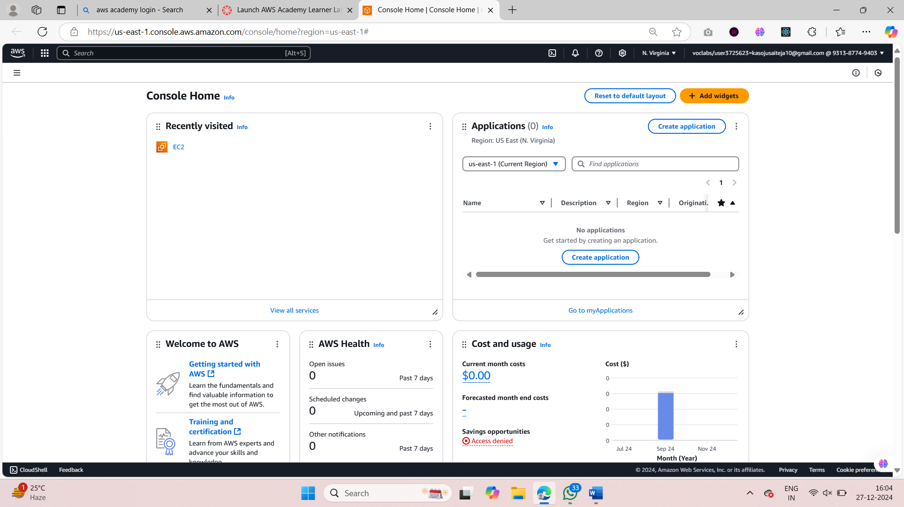

1. Launch an EC2 Instance.

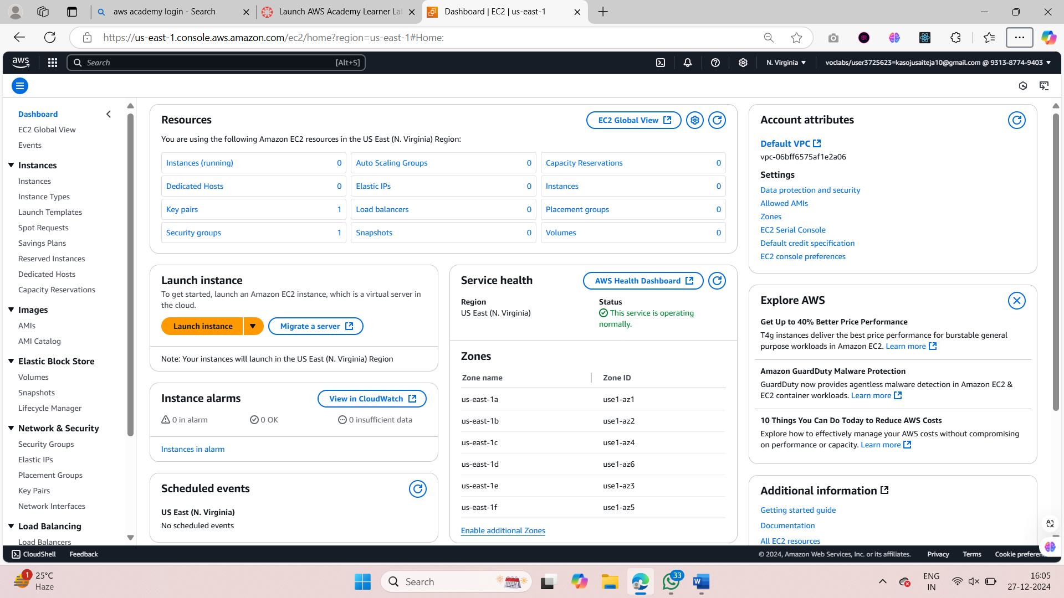

* 1. Now give the name for the instance and select Ubuntu as the OS.

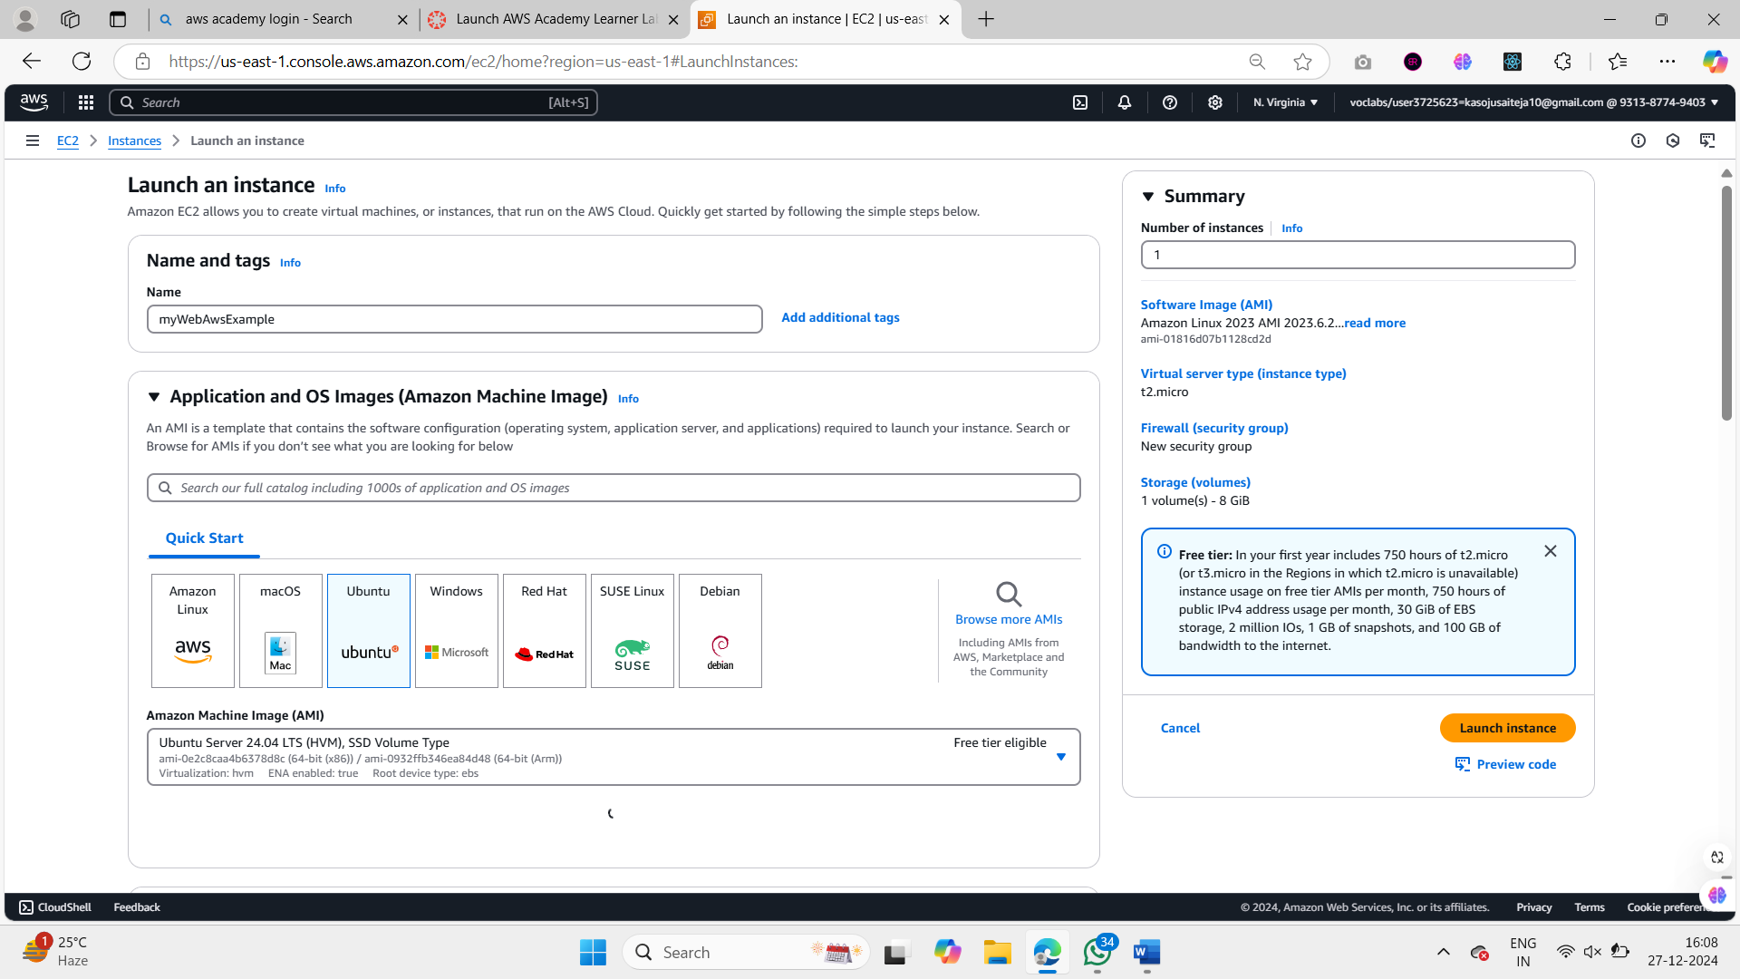

1. Now under the AMI select the first free tier option.

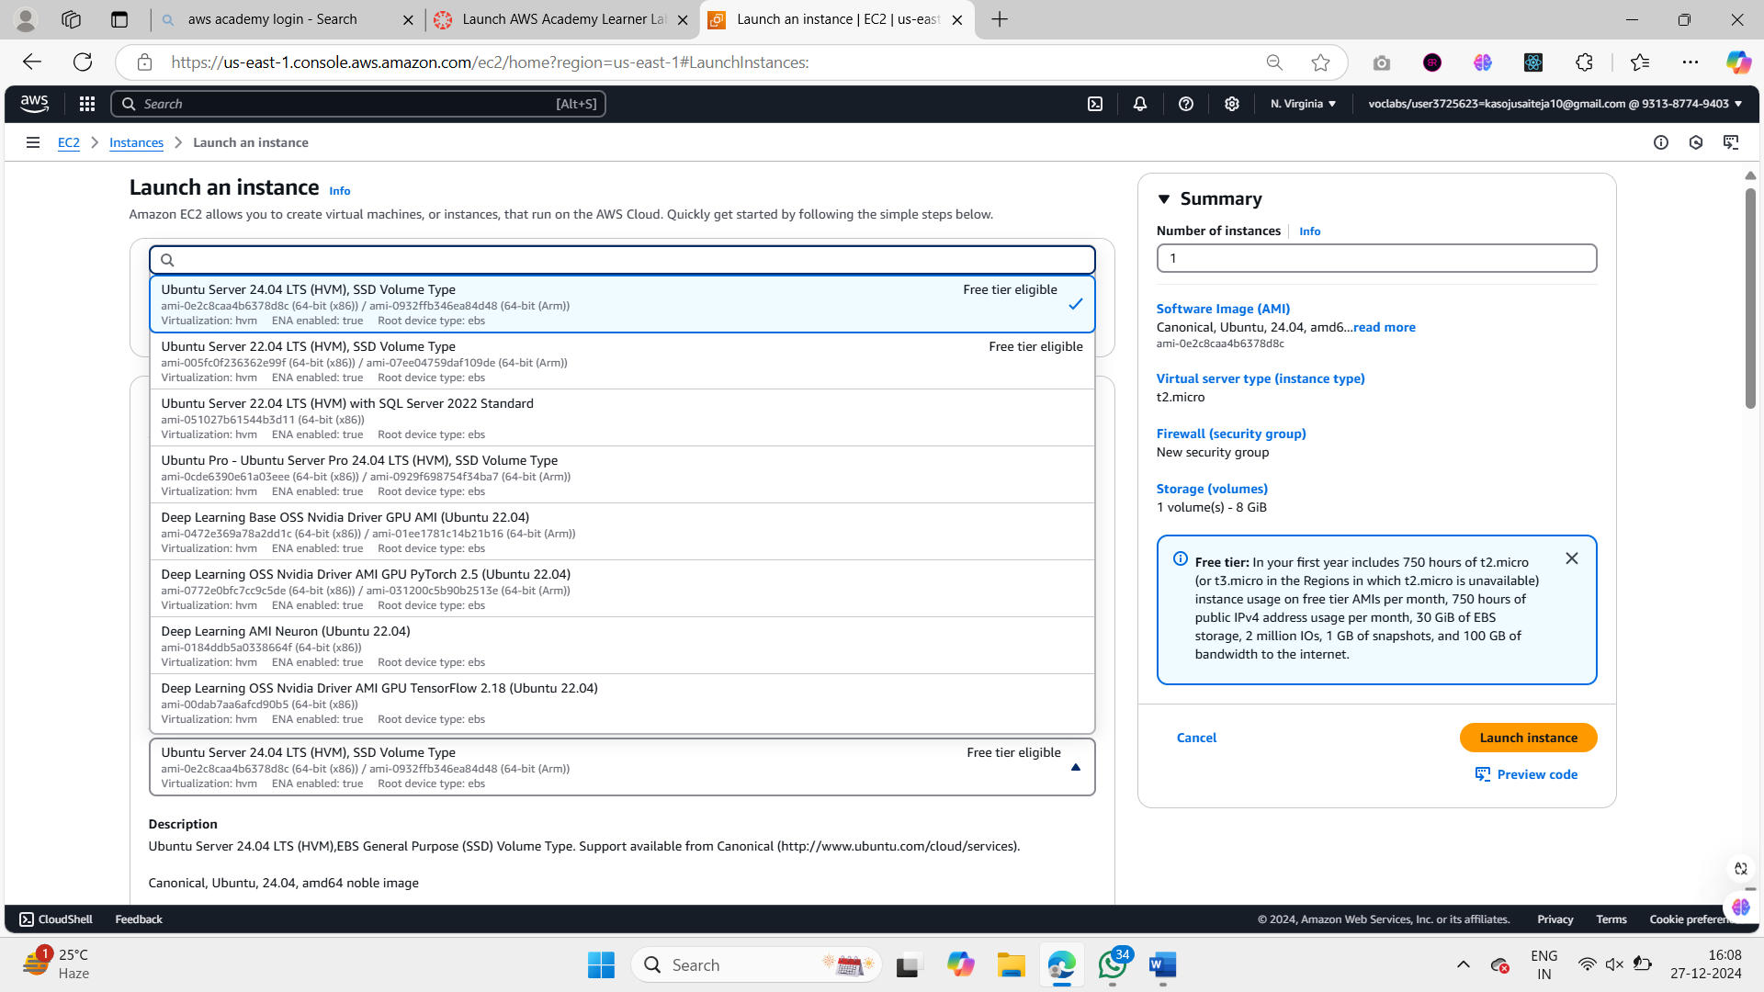

1. Under the architecture select that you prefer here I have select 64-bit(x86).

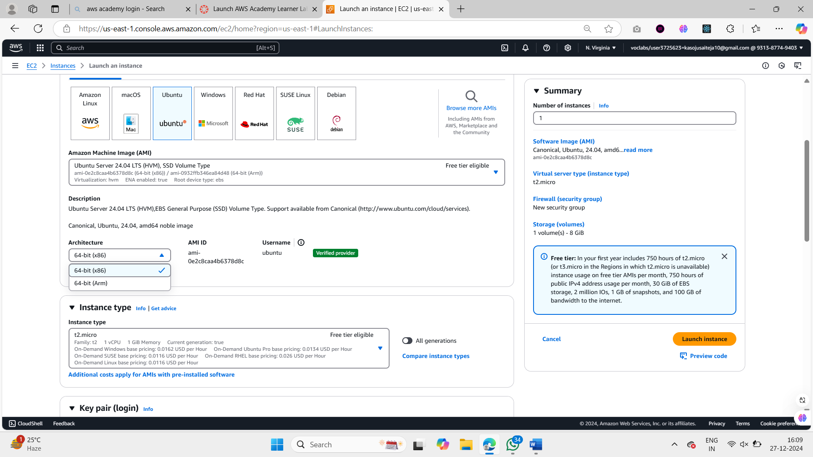

1. Now in the instance type I would like to select the t2.micro instance. And then click on create a new key pair to create a new pair to connect to our ec2 instance securely.

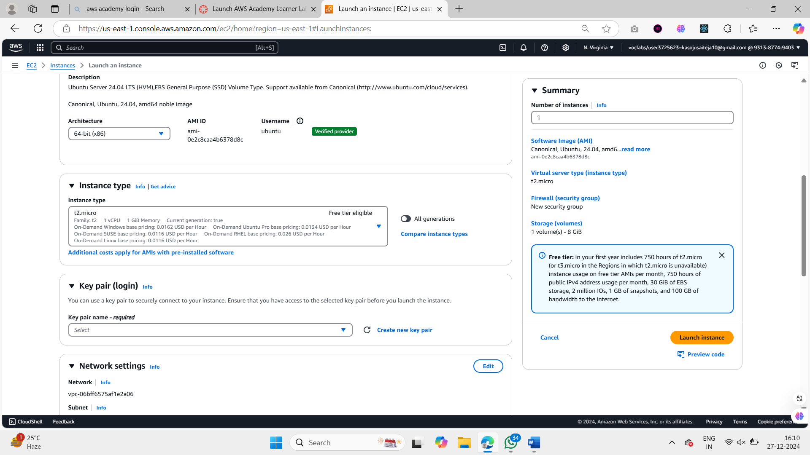

1. Give the name for the Key pair and select RSA, .pem and click on create.

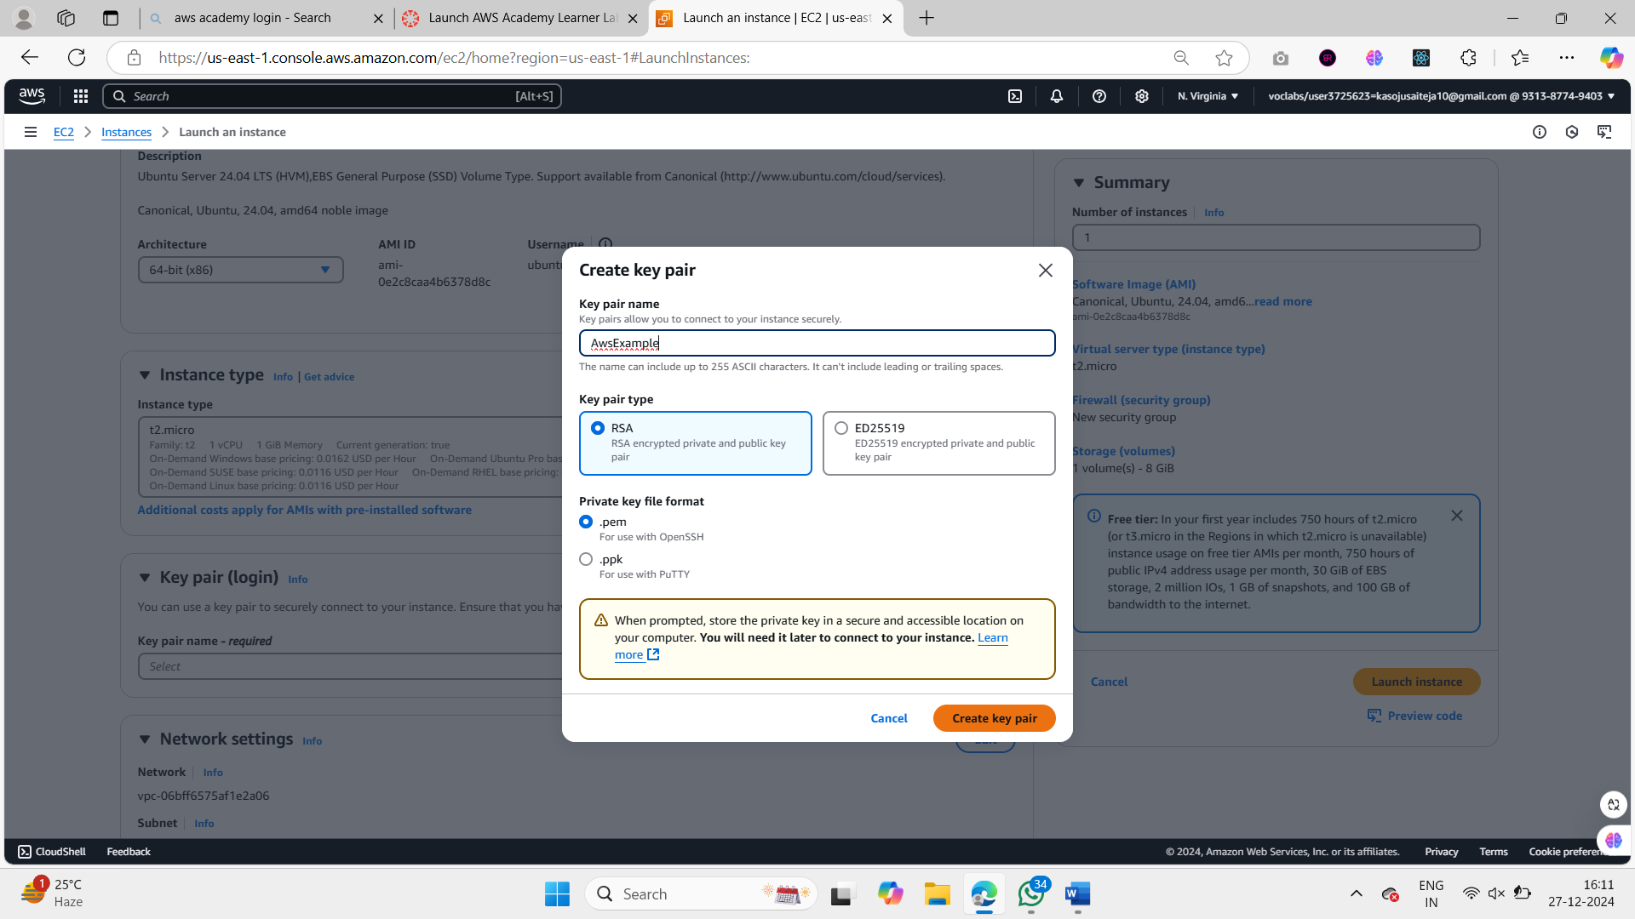

1. Save that .pem file in the one of the folders on your computer.

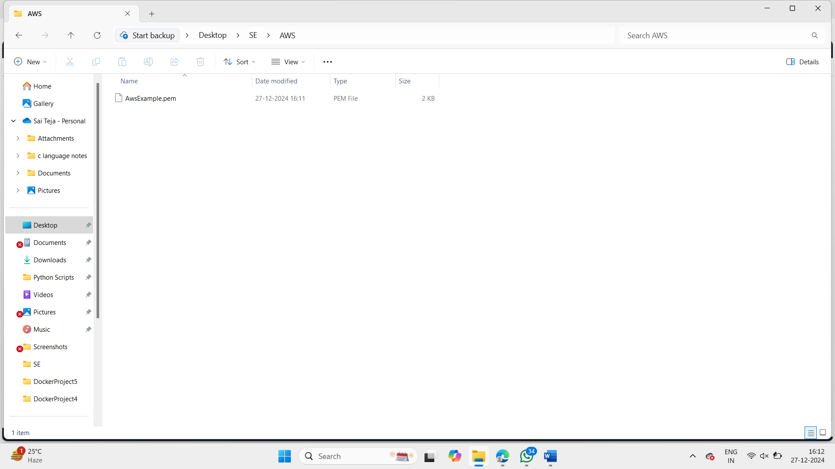

1. Now go back and Under network settings make sure to check Allow HTTPS traffic and Allow HTTP tarffic

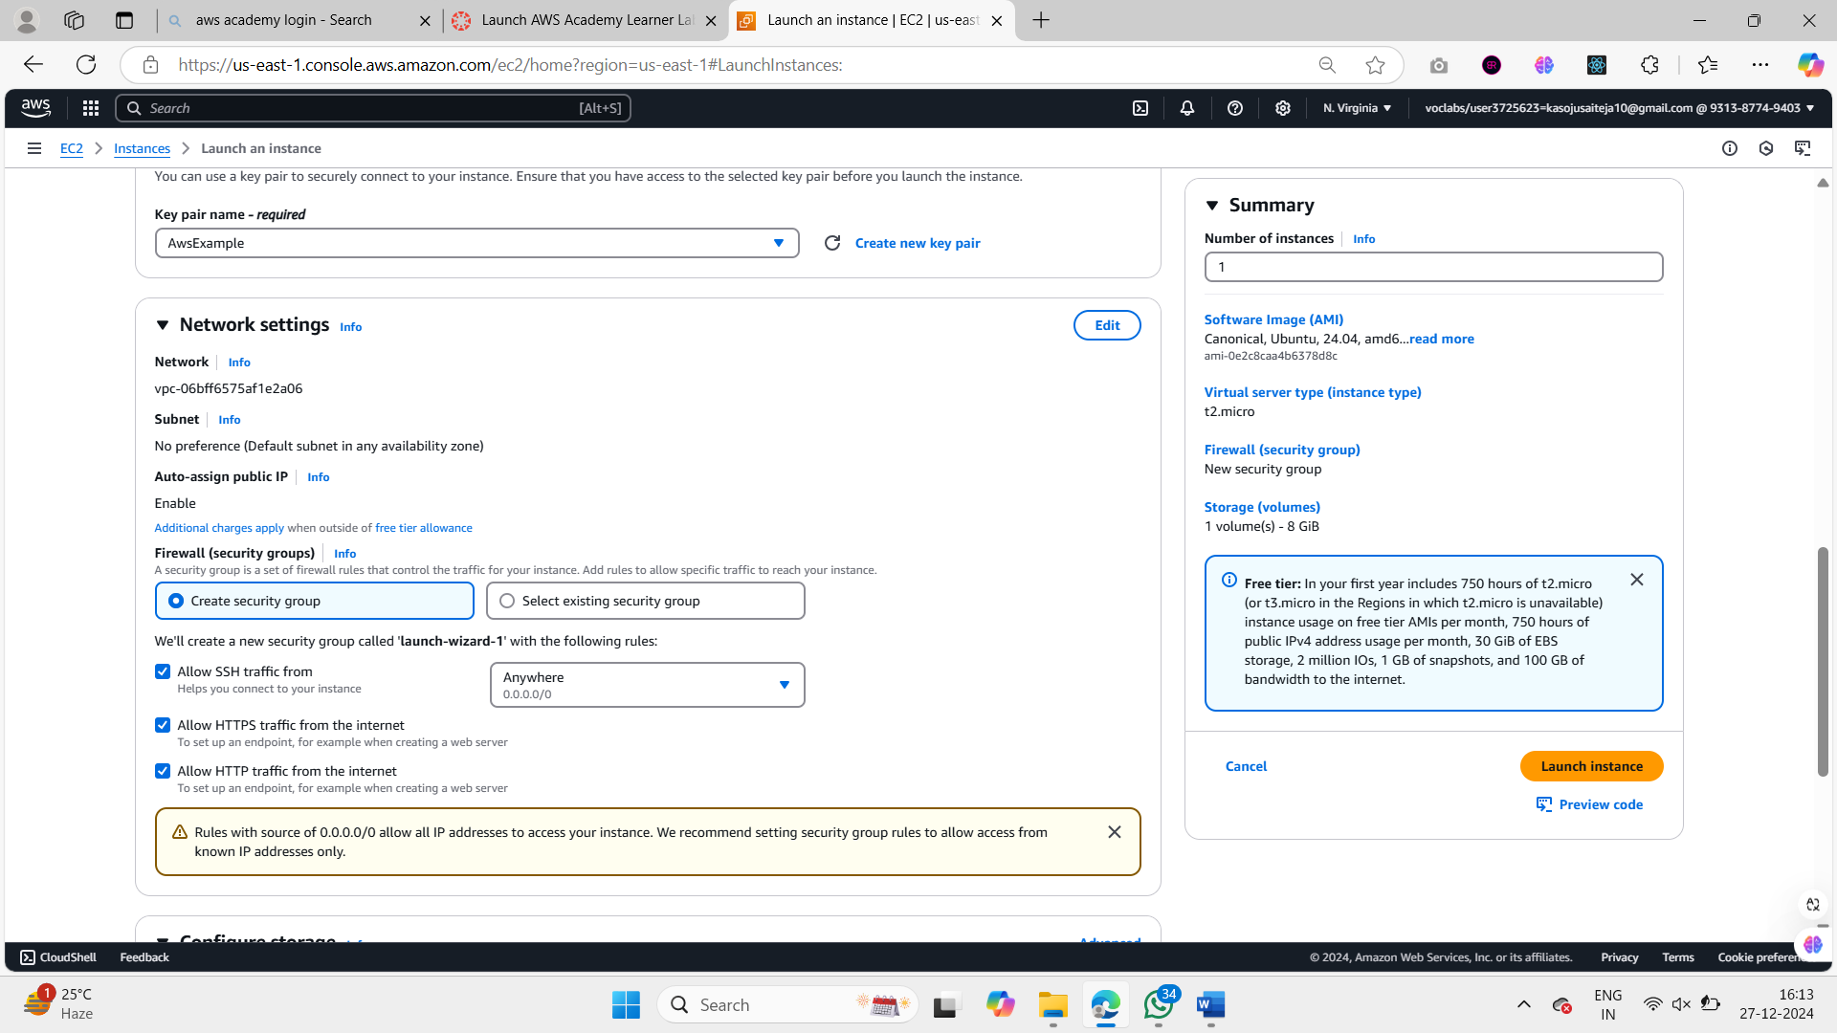

1. Then let the storage be 8GB and then click on launch instance.

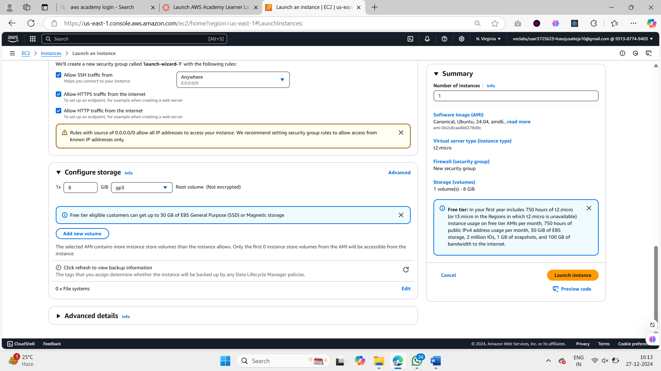

1. Wait for the instance to be created.

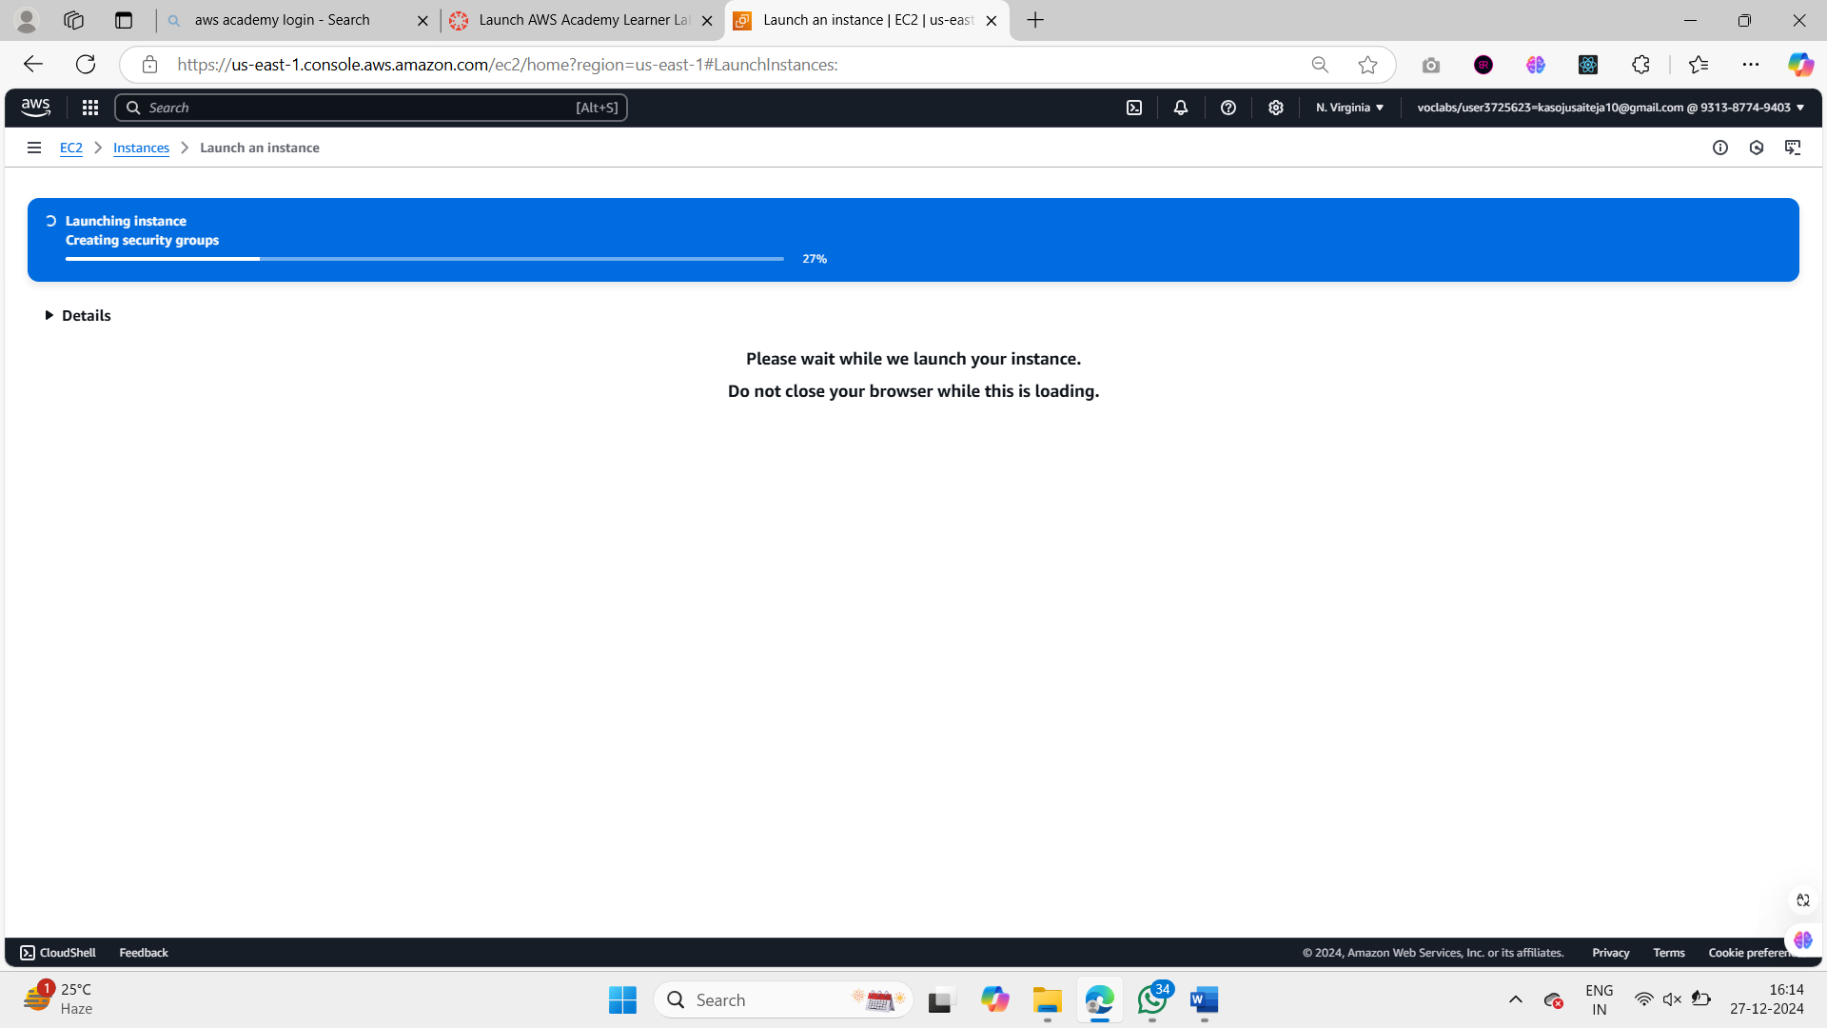

1. after the instance is created go back to the Instances dashboard.

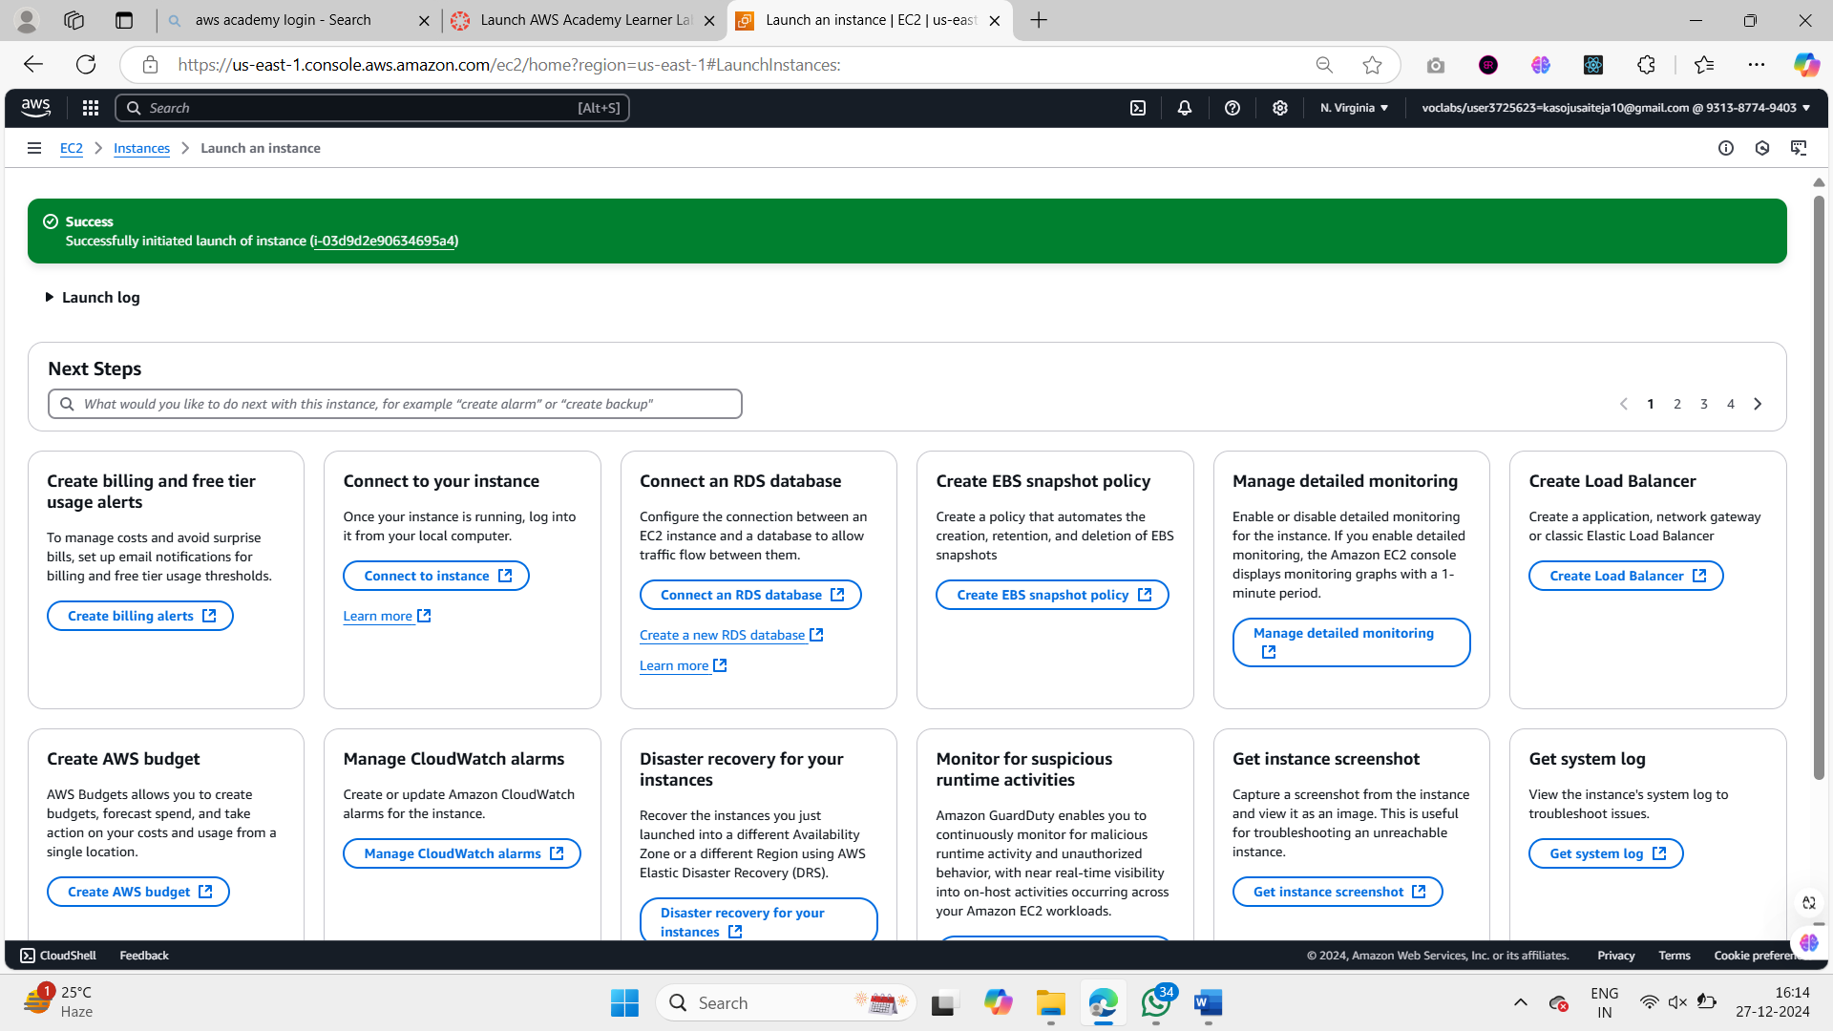

1. Now wait for the instance to get 2/2 status check. (it may take some time)

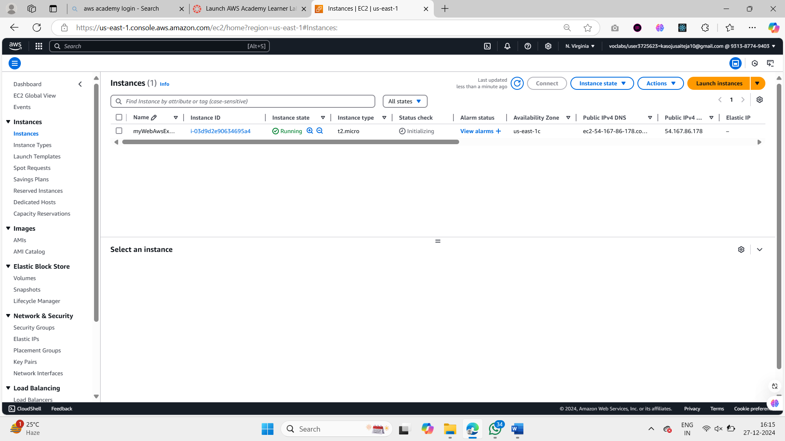

1. In the mean time , Go to github and create a new repository.

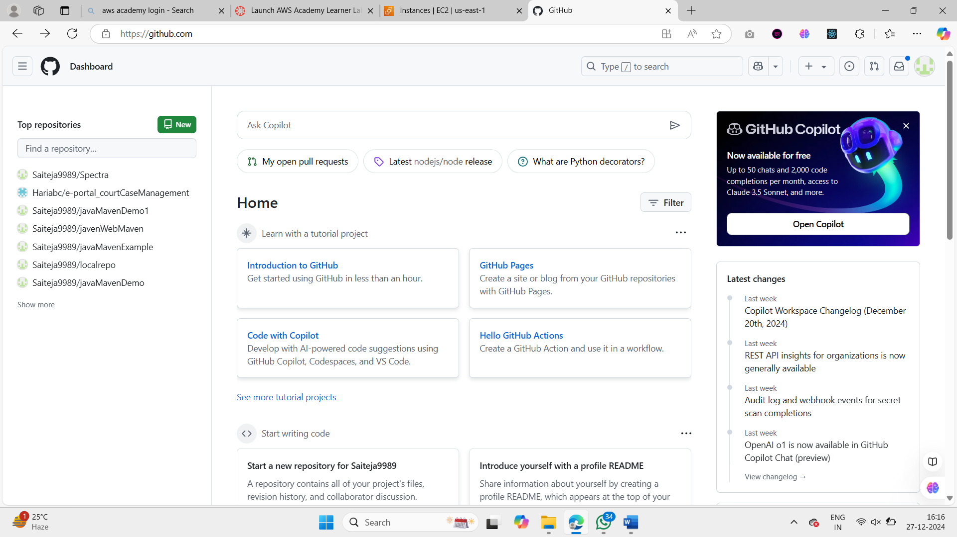

1. Creating a new Repositoy.

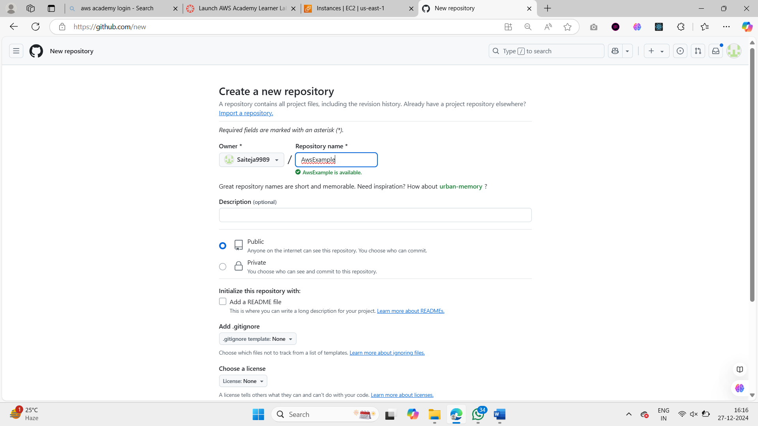

1. Copy the HTTPs Url of the Repository to connect to it.

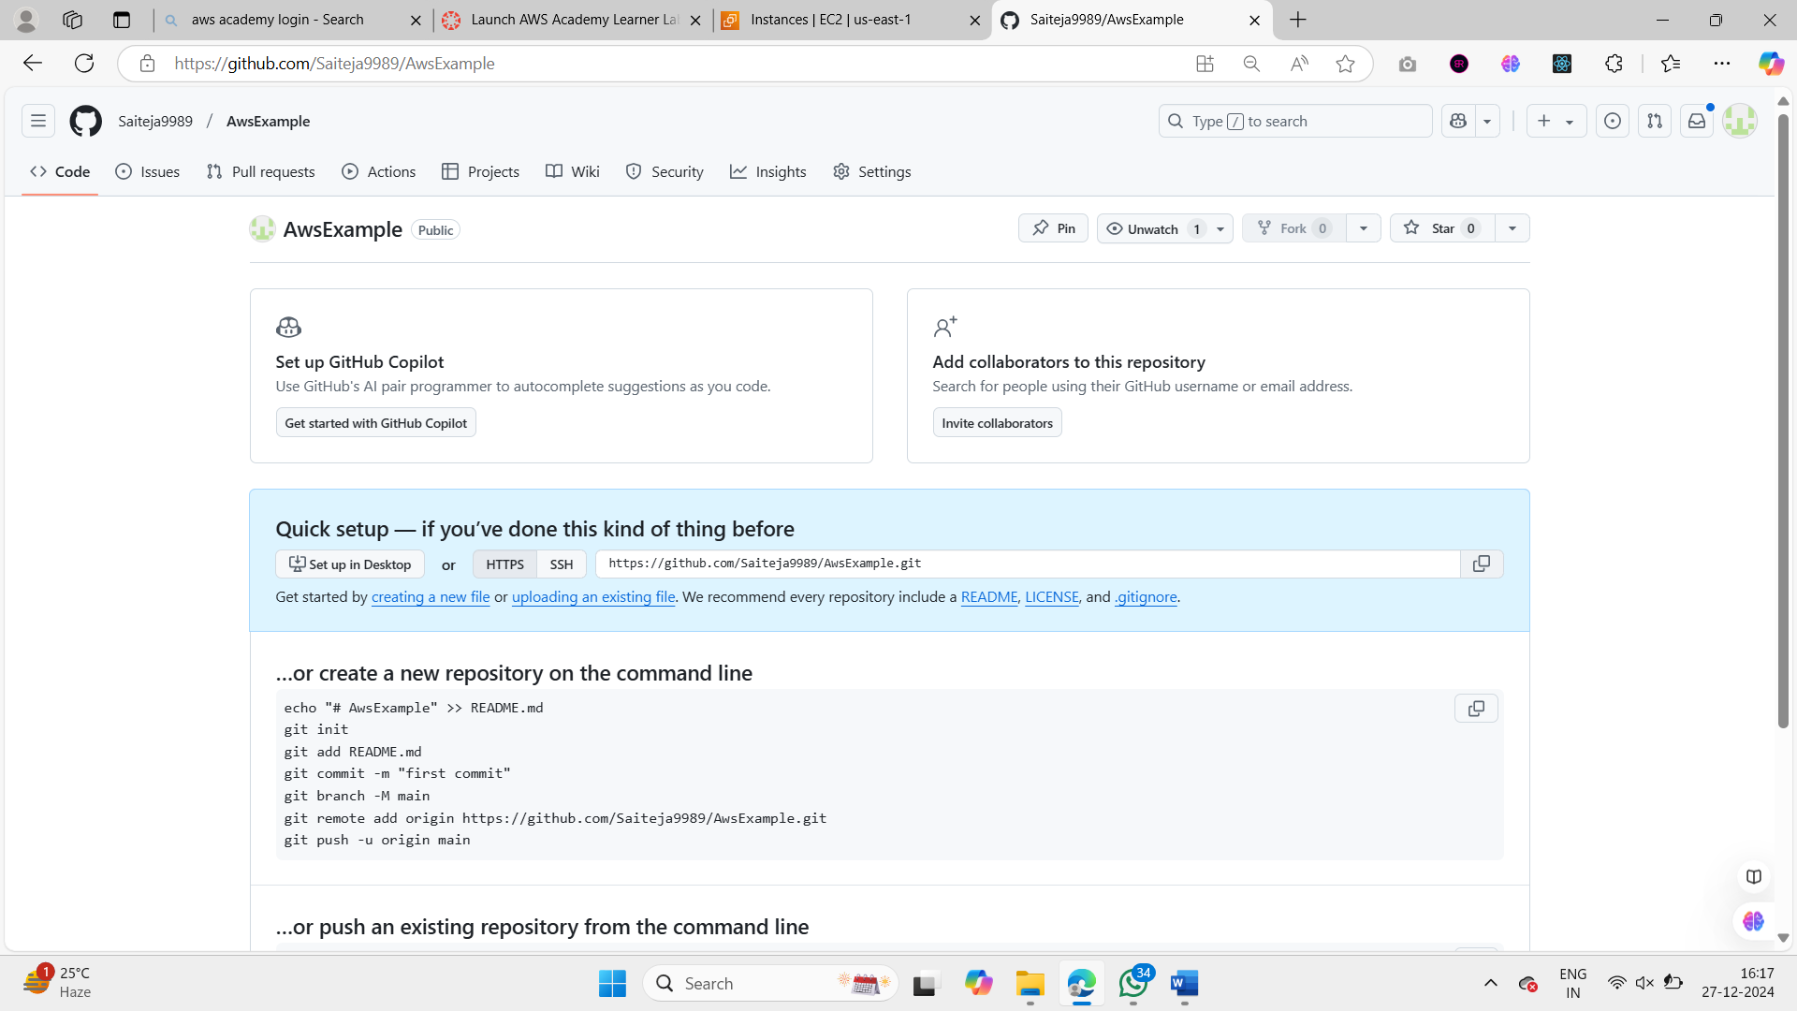

1. Go to some location in Your computer and create a index.html file and write the below basic code.

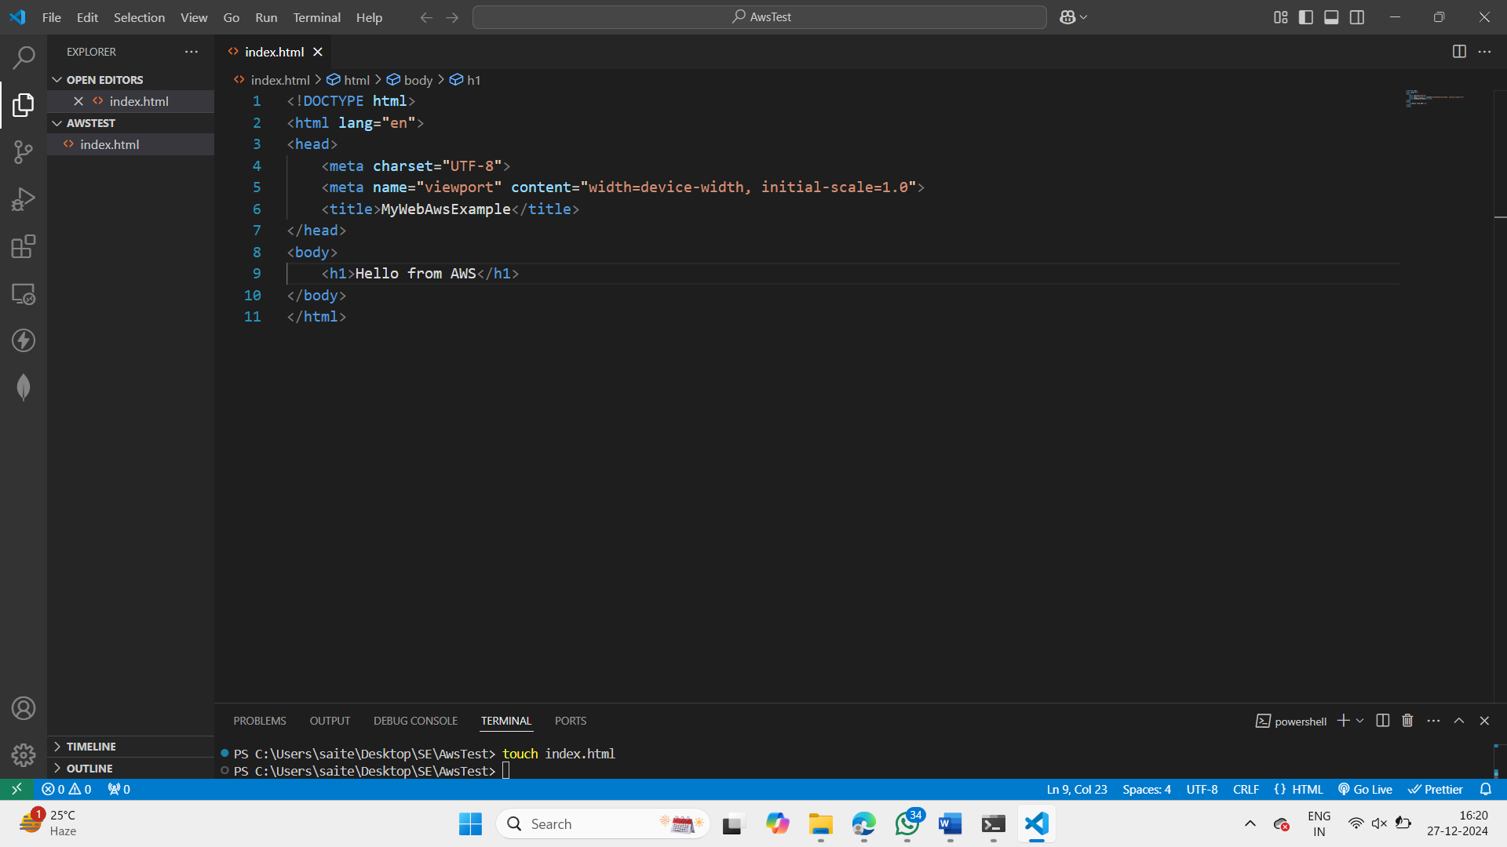

1. Now open the Git bash in the folder where you have your index.html.

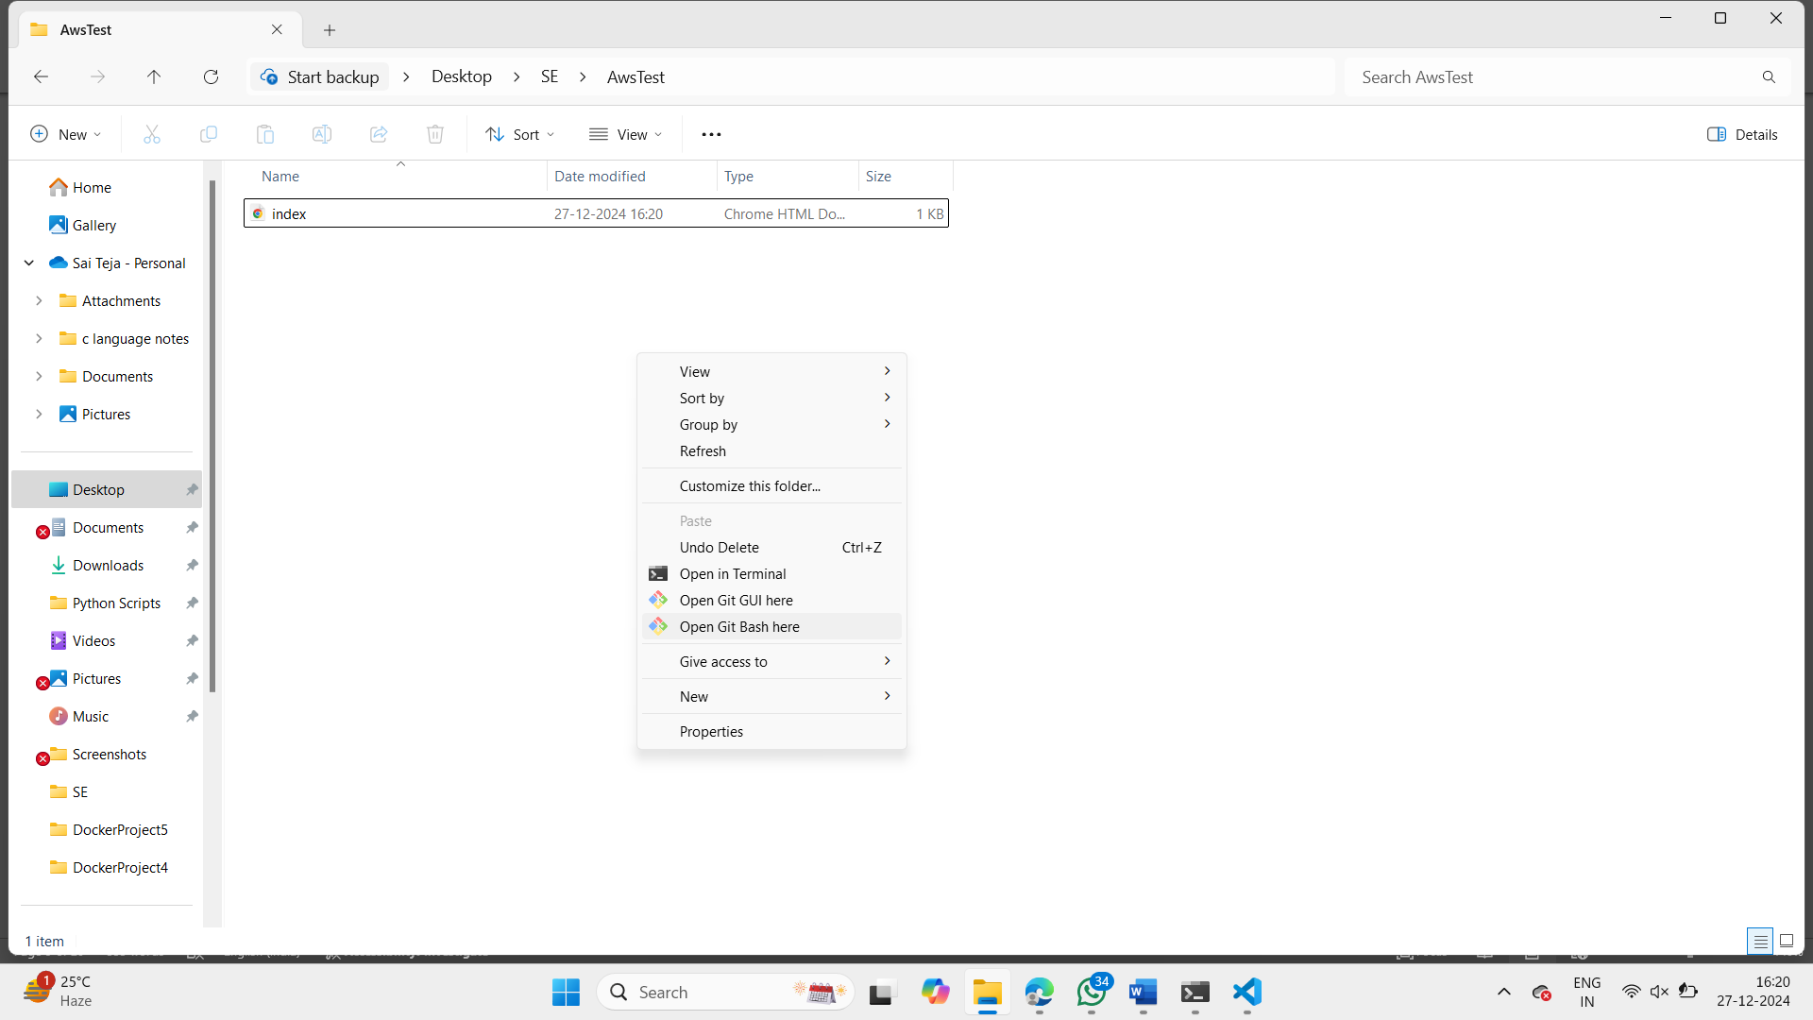

1. Initialize a git repository and use add and commit commands to commit the changes.

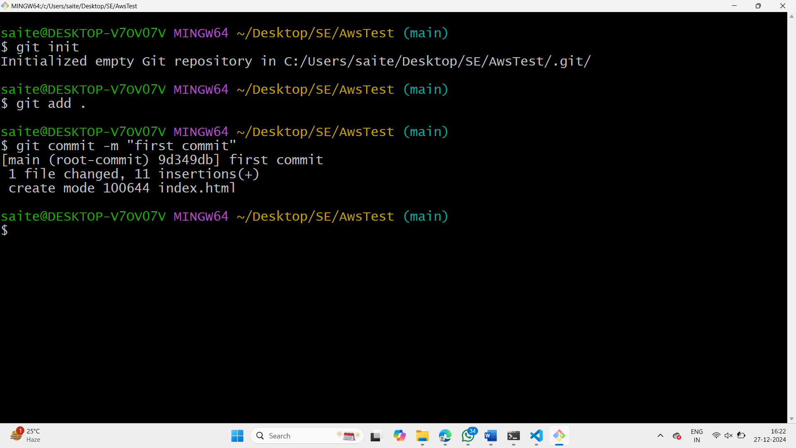

1. Go to github and copy the remote commands.

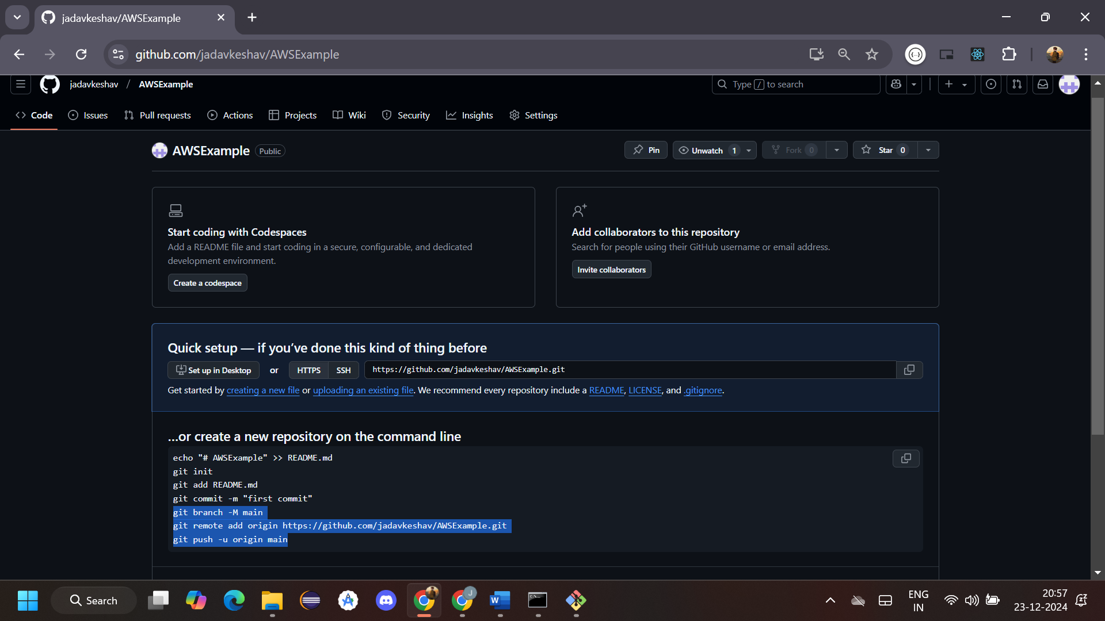

1. Now paste the remote commands to push our index.html file to the github.

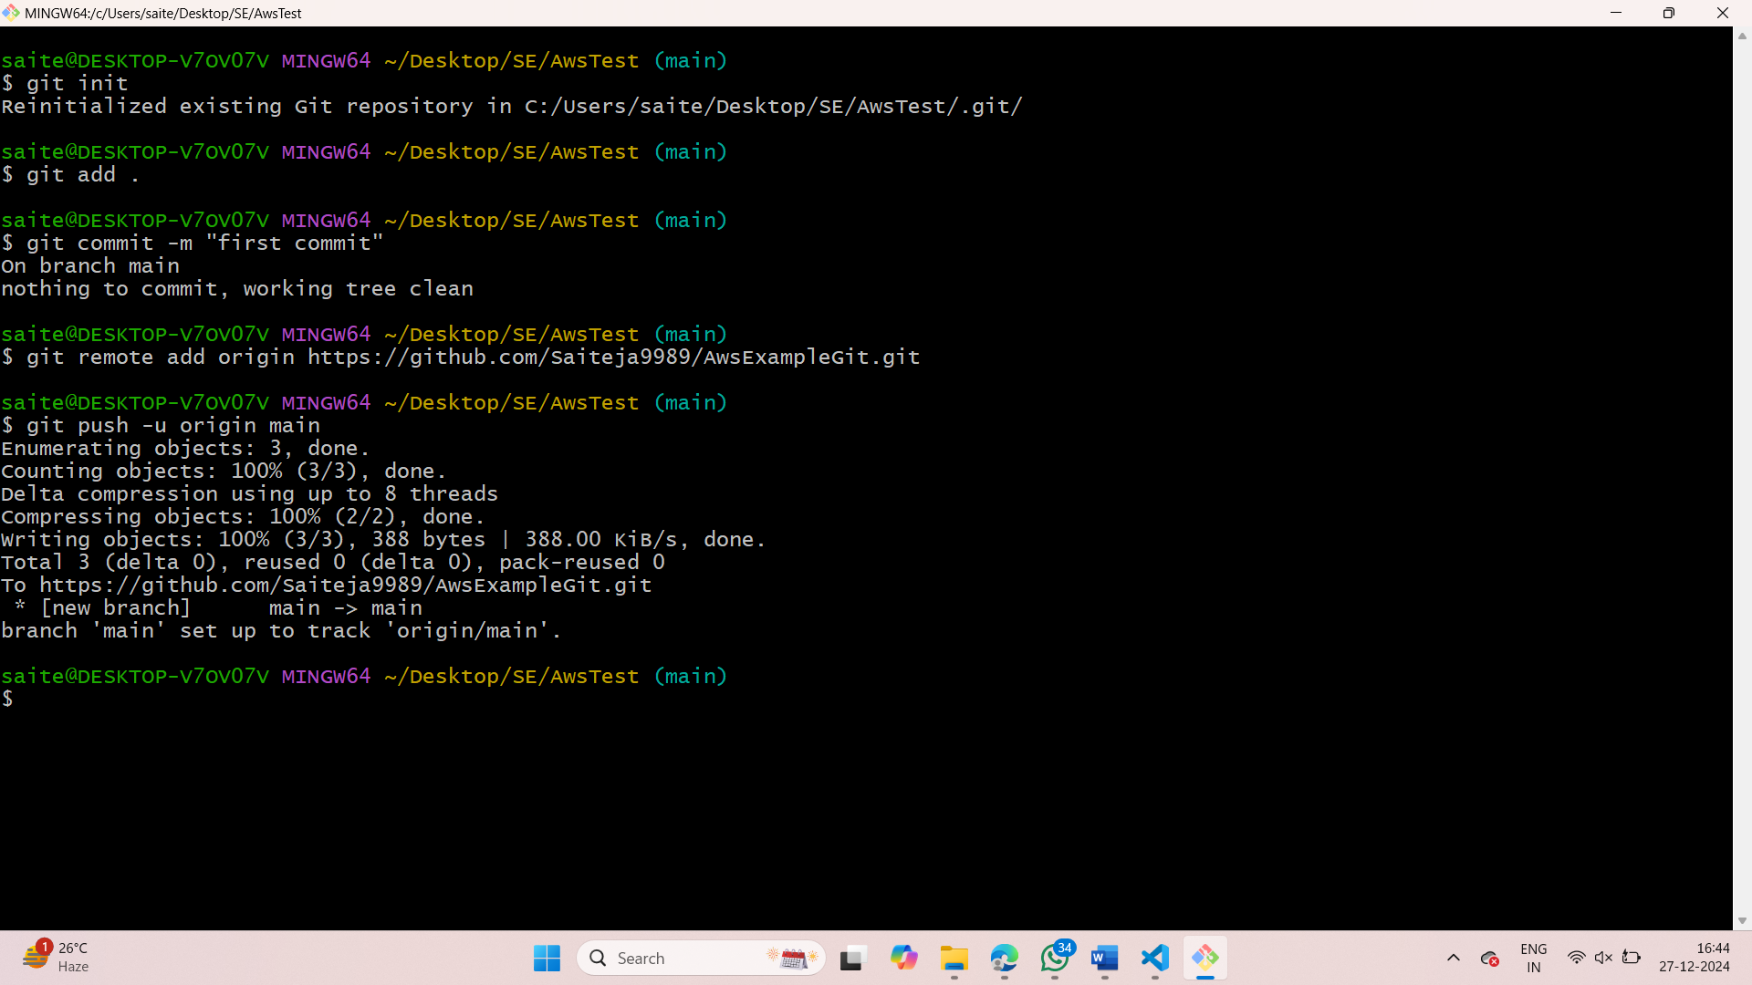

1. Now coming back we can see that our instance has passed 2/2 status check. Now select that instance and click on connect.

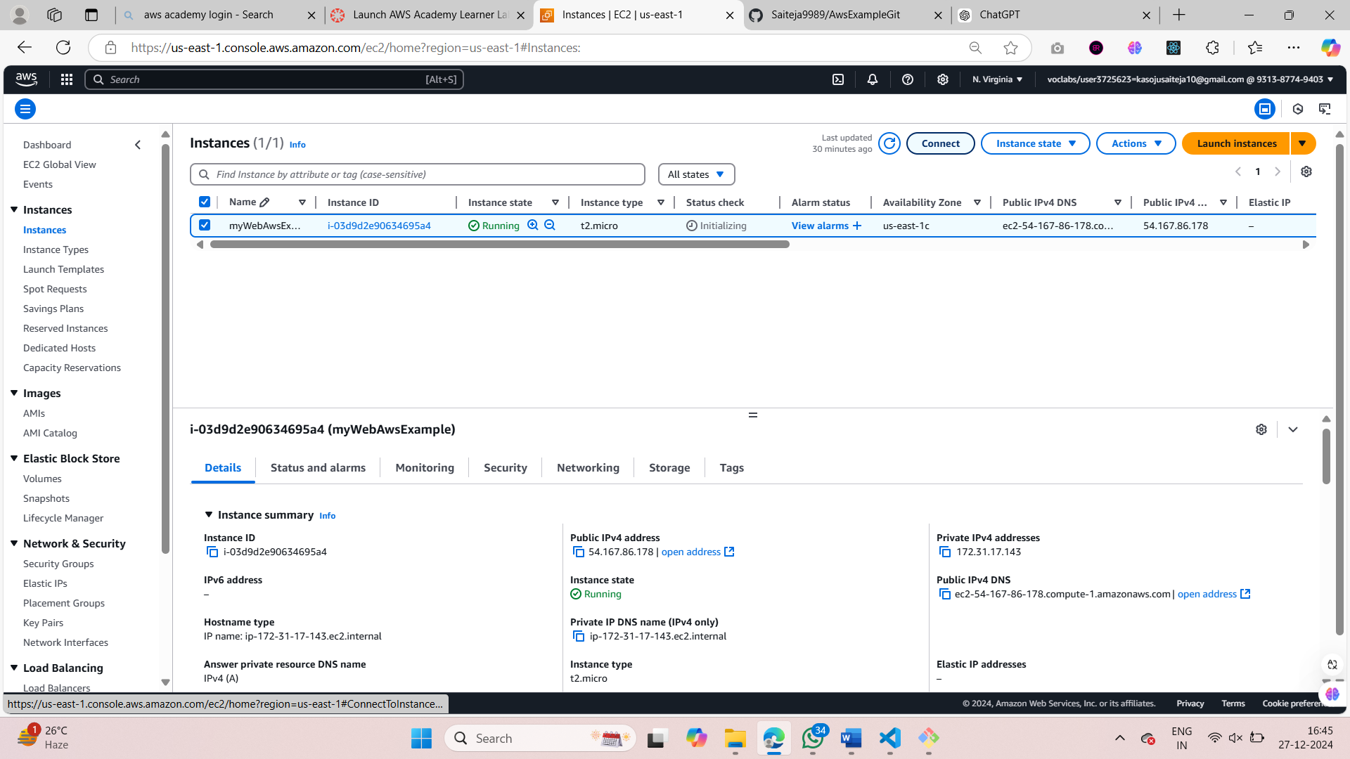

1. Now copy the last Example code / statement.

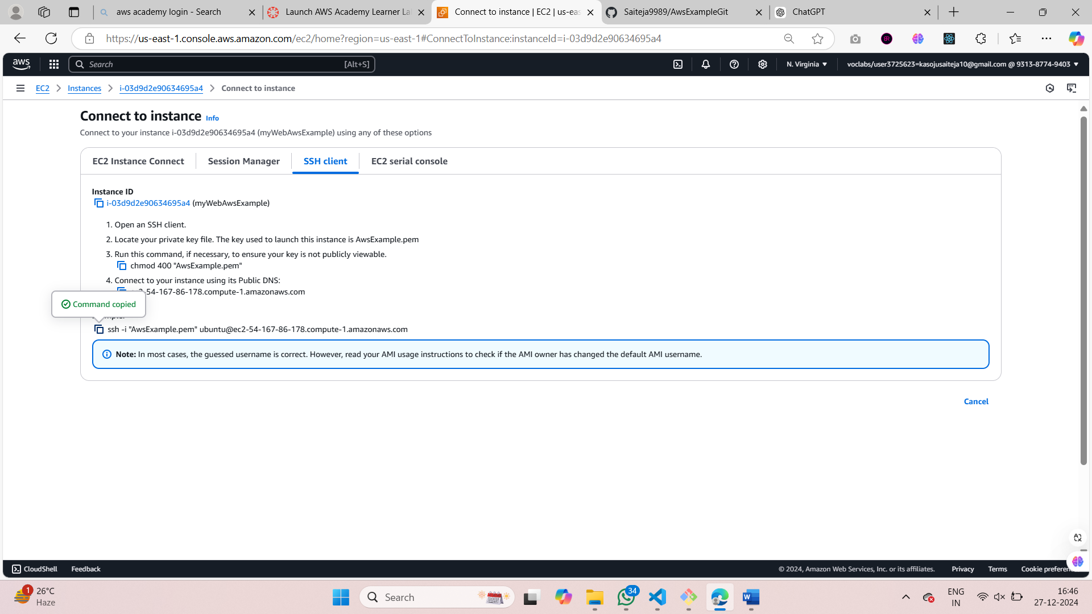

1. Open the cmd prompt in administration mode and navigate to the folder where you have saved your key .pem file.

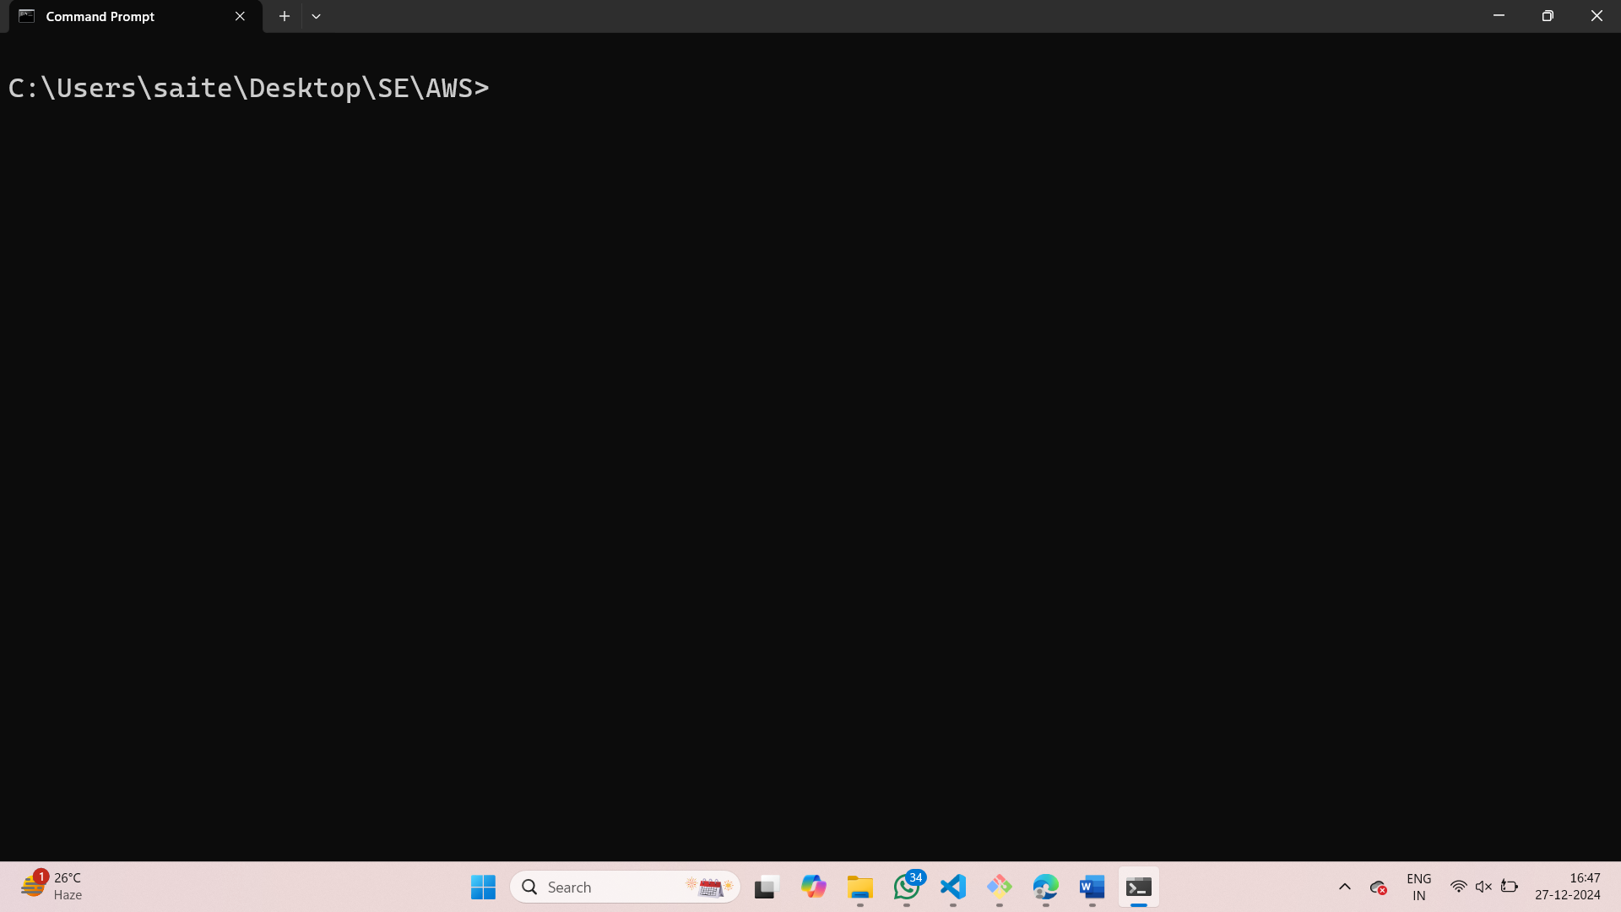

1. Now paste the command that you have copied. And give yes as option for fingerprint.

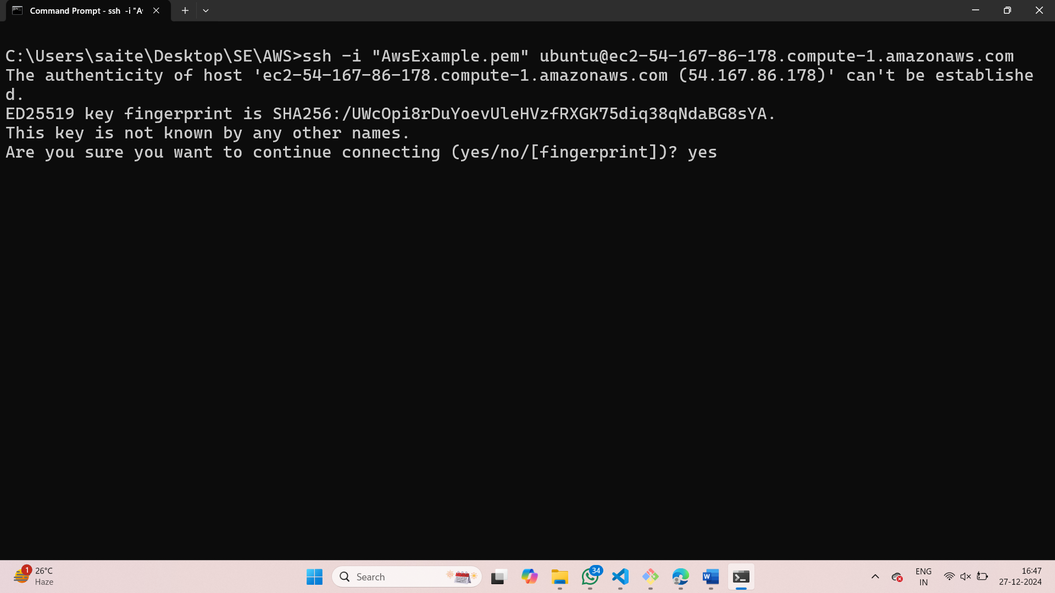

1. You have successfully connected to your ec2 instance.

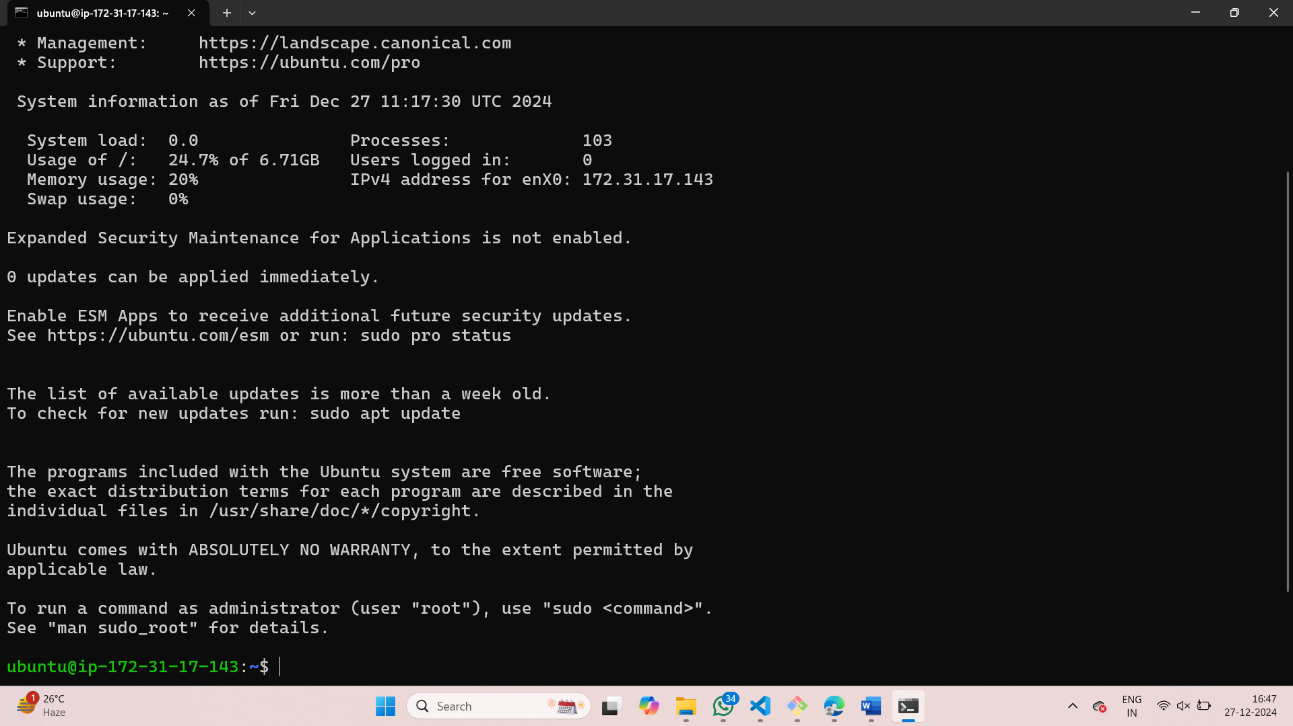

1. Firstly update the ubuntu by using the command sudo apt update.

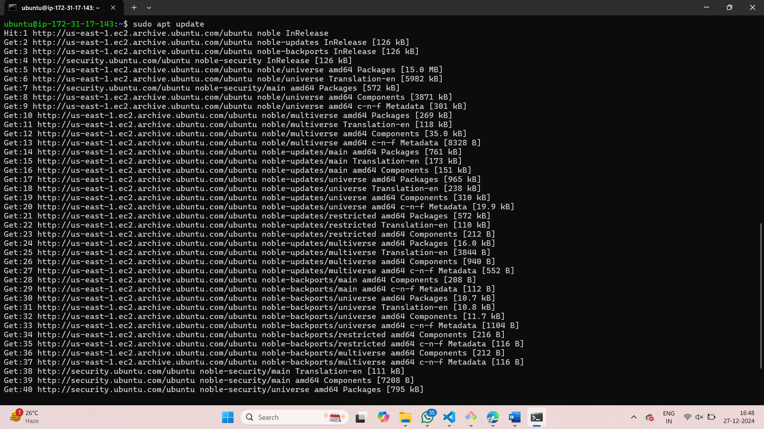

1. Then install the docker using sudo apt-get install docker.io

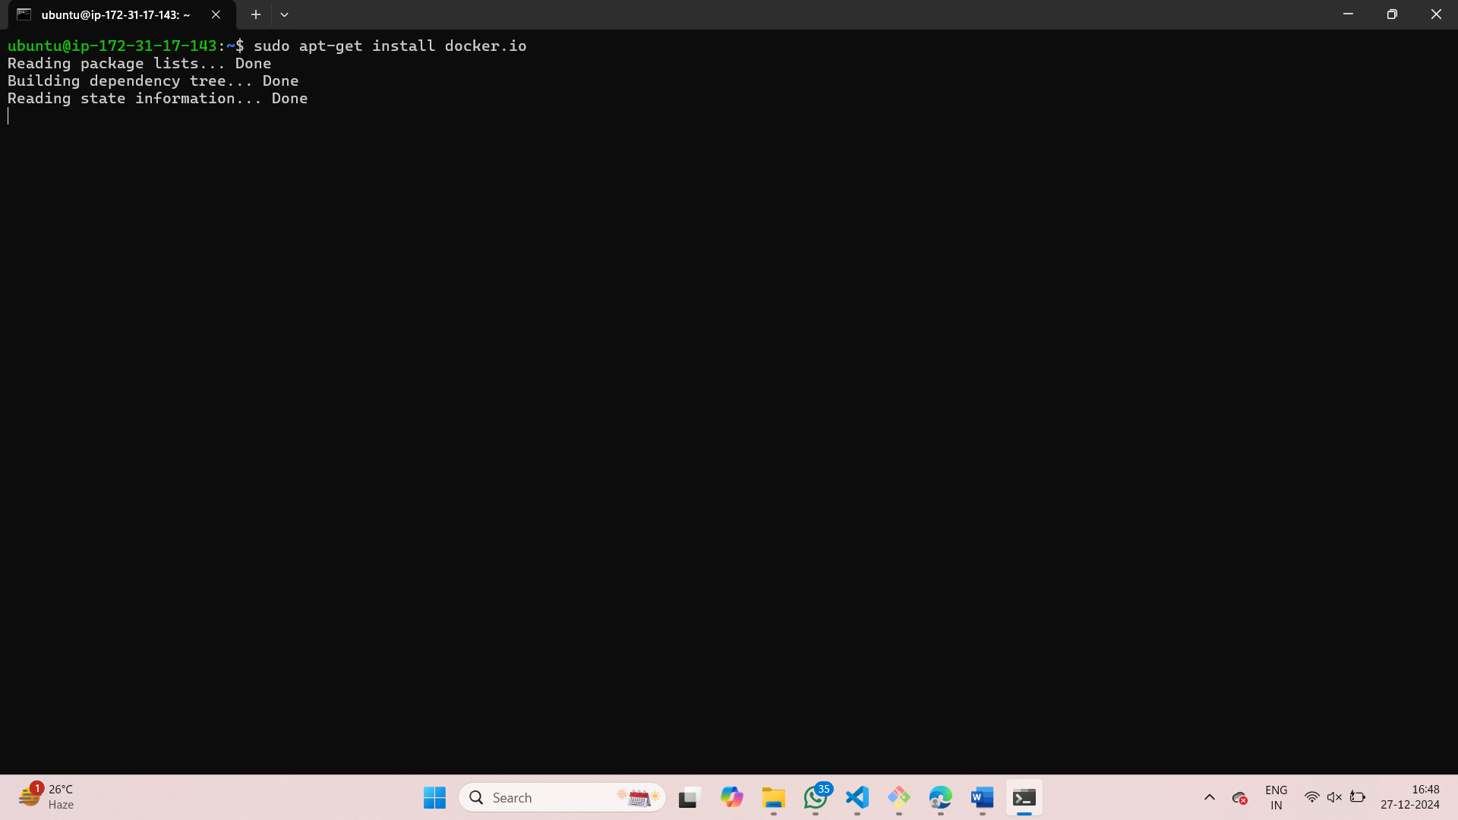

1. Installing git using sudo apt install git.

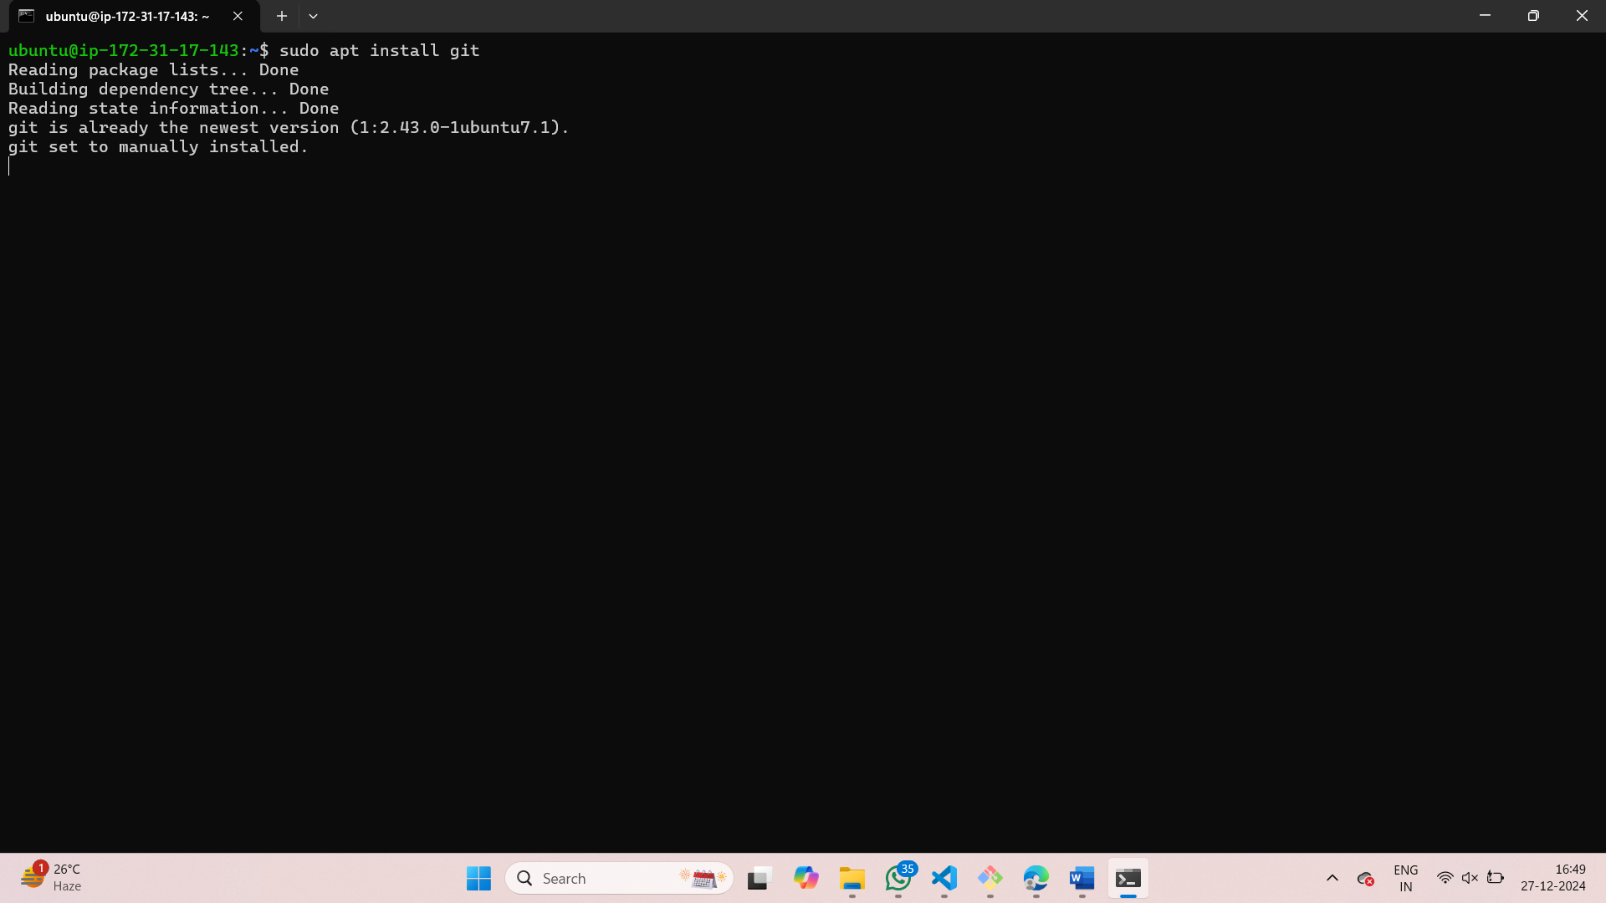

1. Install nano using sudo apt install nano.

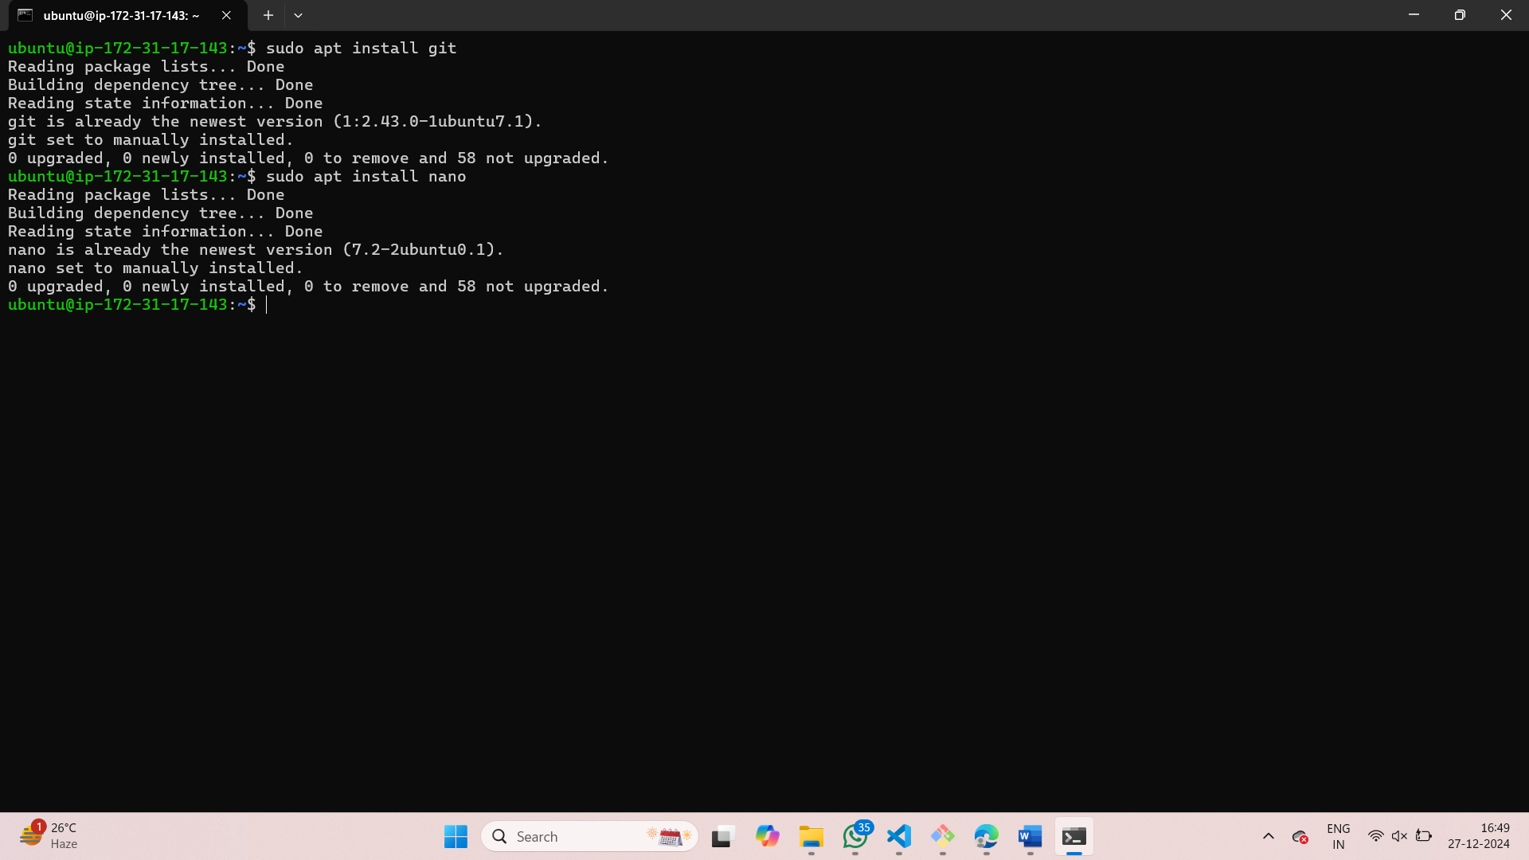

1. Go back to github and copy the Url to clone it.

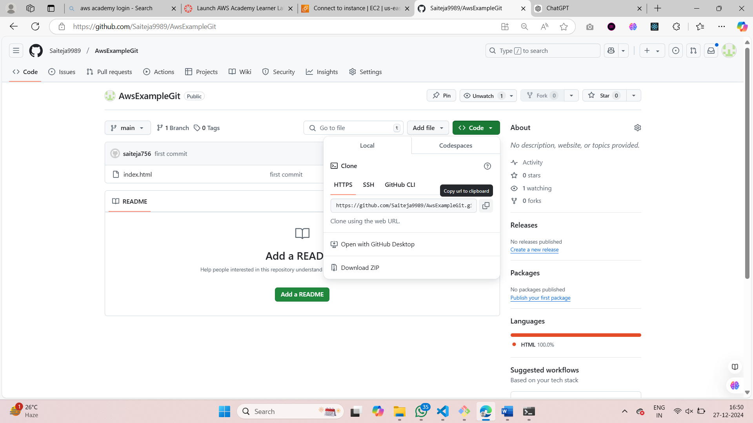

1. Clone your github repository into the ec2 instance.

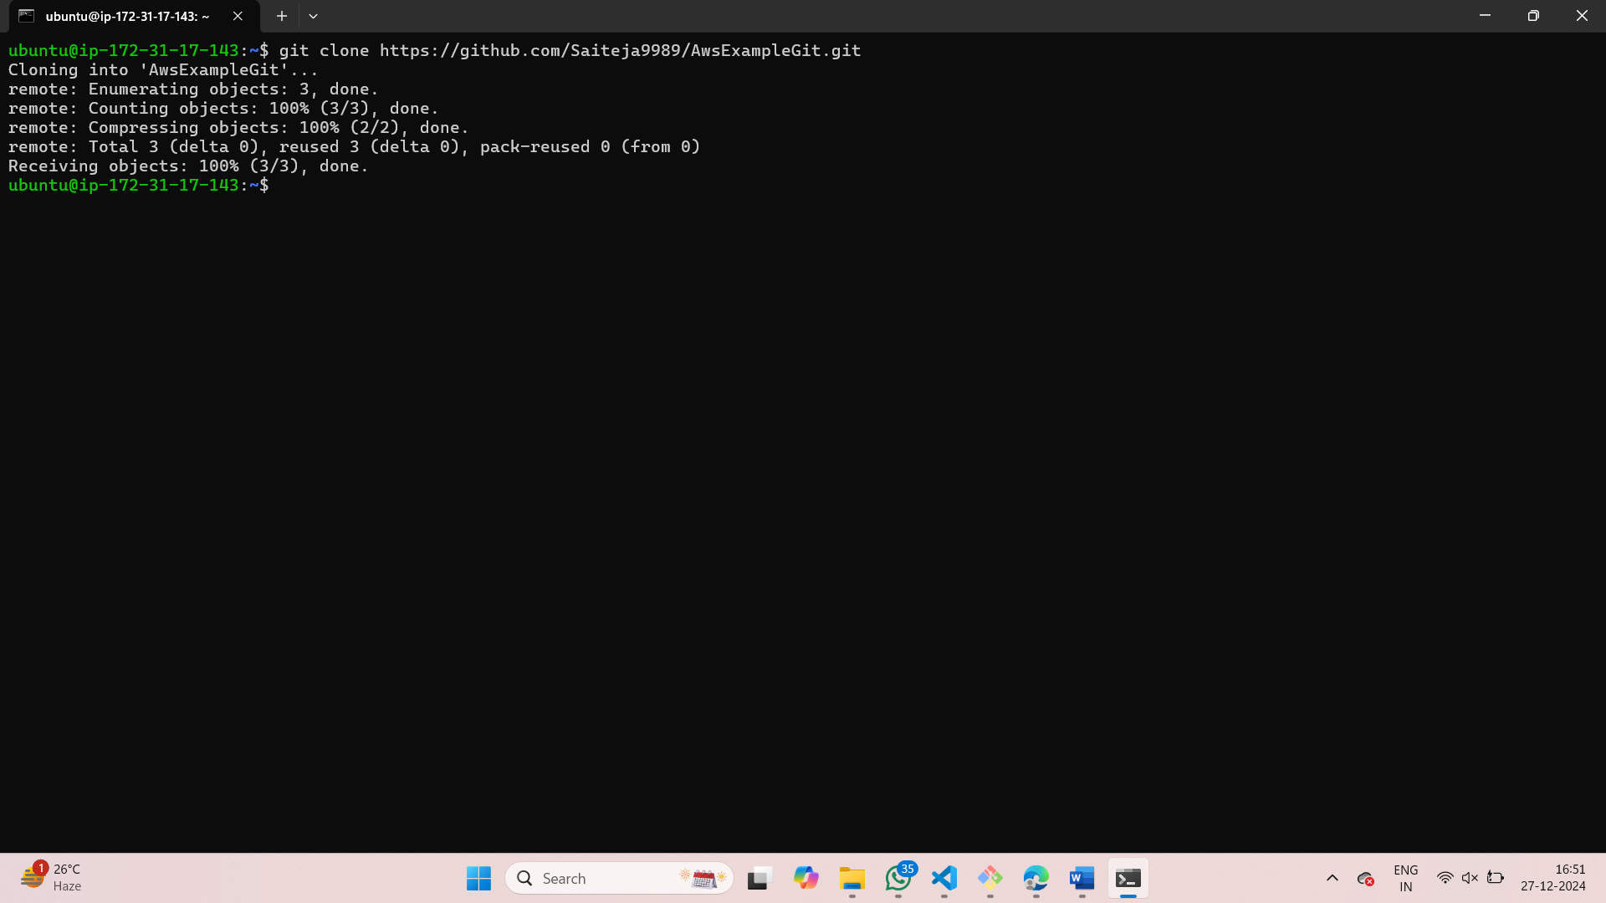

1. Now navigate to the folder that we just cloned and create a Dockerfile there using nano Dockerfile.

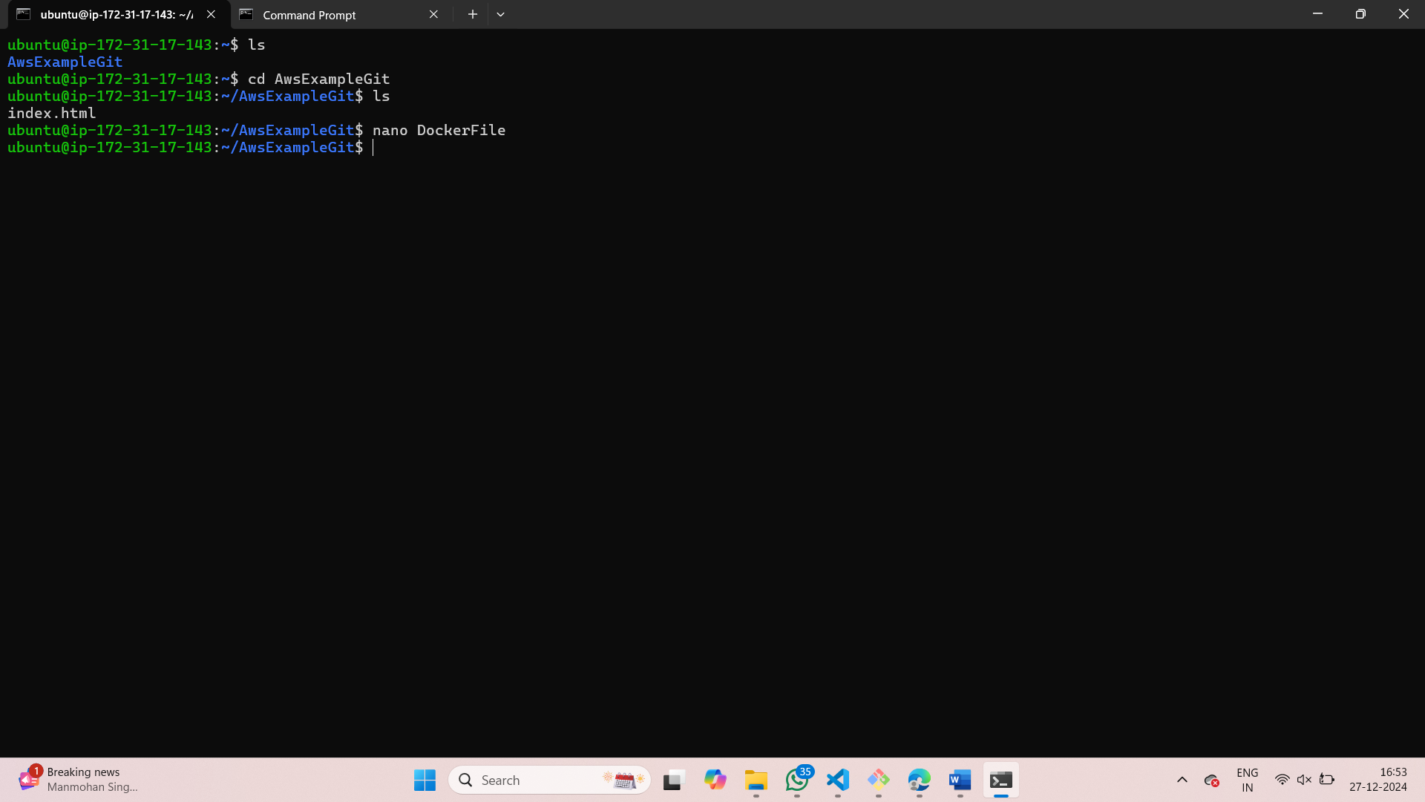

1. Add the following content:

FROM nginx:alpine

COPY . /usr/share/nginx/html

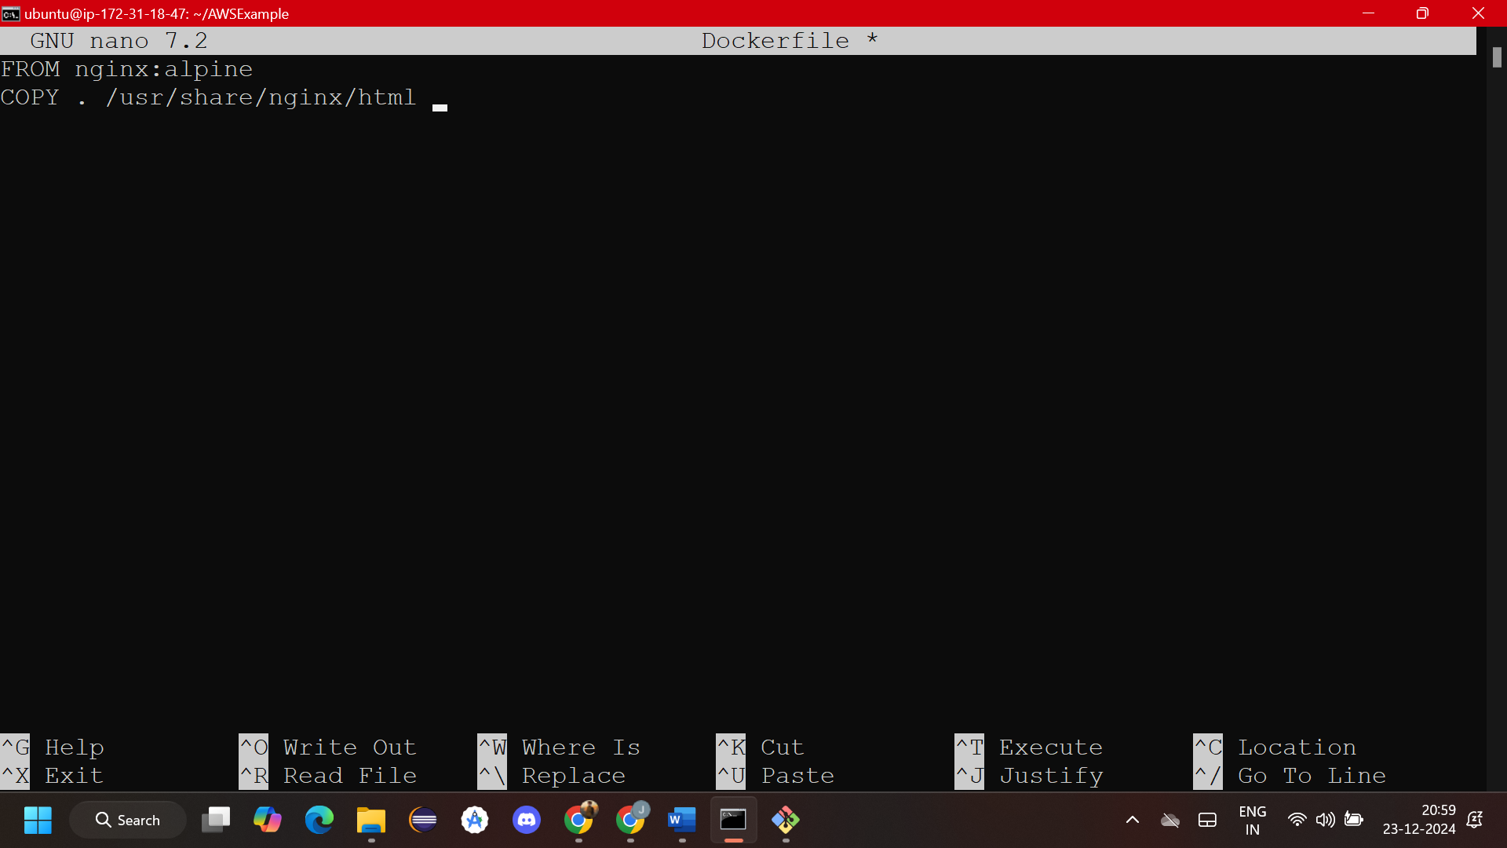

1. Build the Docker image using sudo docker build -t my-web-app .

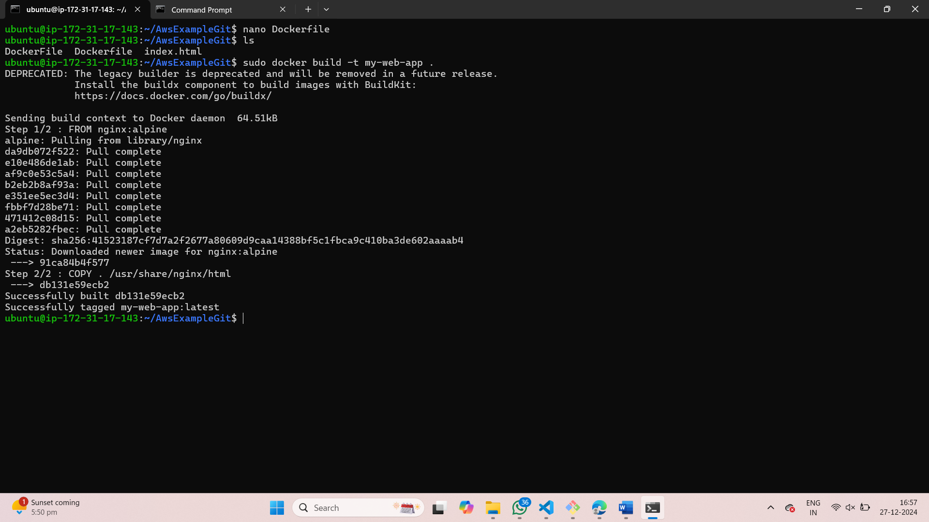

1. run the Docker container to serve the web application. Using sudo docker run -d -p 80:80 my-web-app

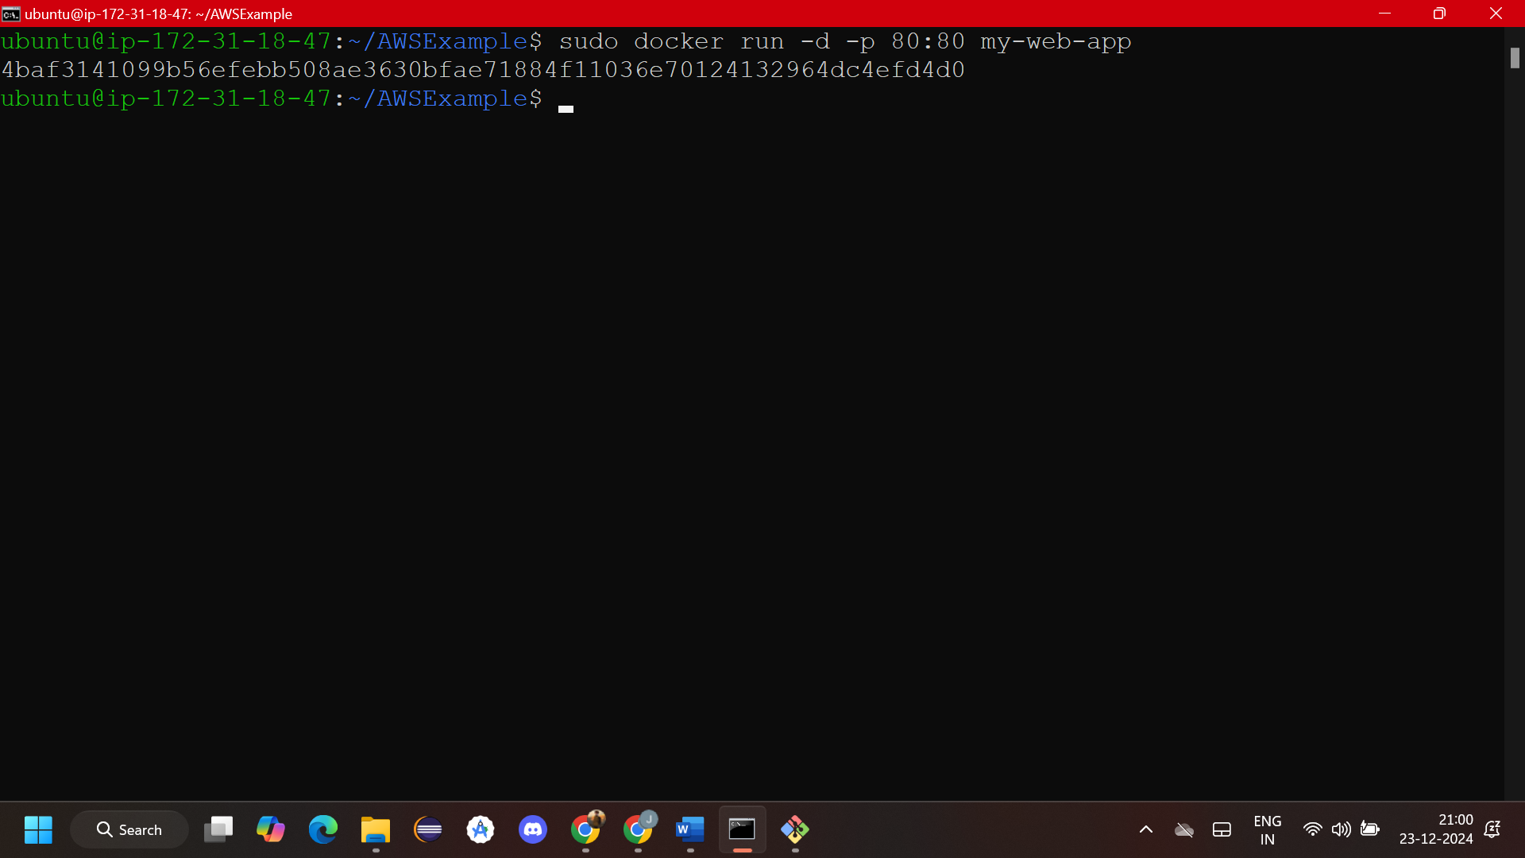

1. go back to your ec2 client dashboard andCopy the Public IP Address of your EC2 instance from the AWS console.

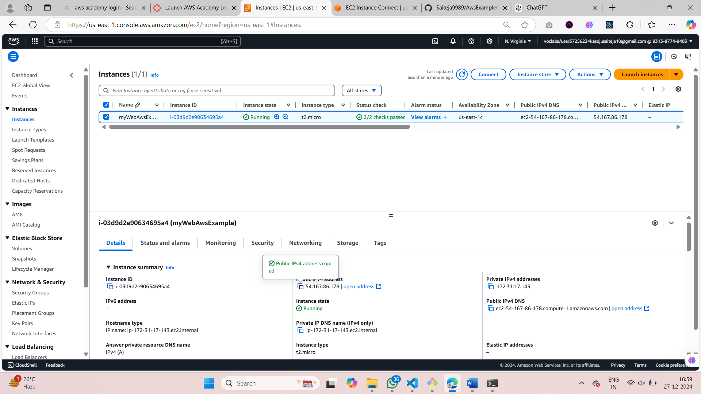

1. Paste it into your browser (e.g., <http://52.91.171.130> ). You’ll see your web page with the message "Hello from AWS!" displayed.

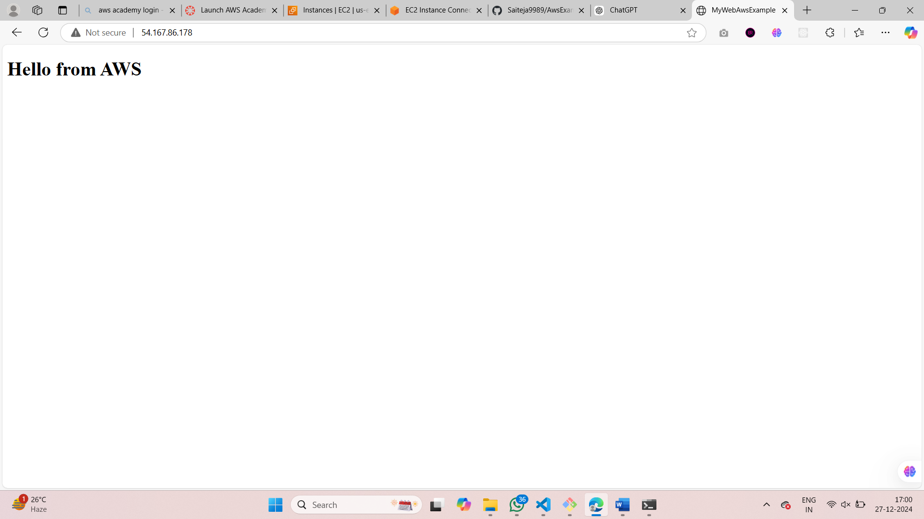

1. Now select the instance and select instance state > Terminate(delete) instance.

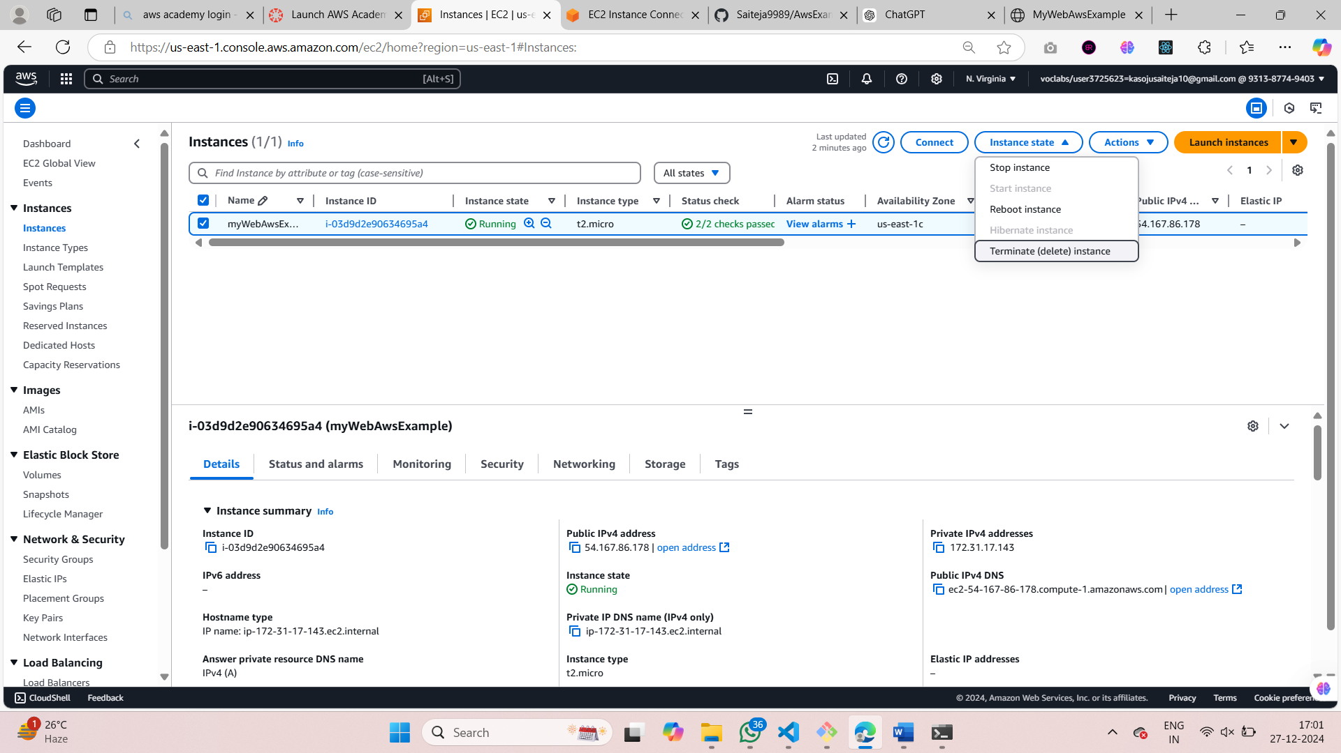

1. Wait for the instance to be terminated.

